PHS Parent Council
13 September 2023
Peebles High School, New Sports Hall

Attendees

Ellie Johnstone, Chair | Claire Barrett, Secretary
Tristan Compton, Buildings Sub-group Lead | Dawn Johnnstone, Communications Lead
Eric Nightingale, Friends of PHS SCIO representative | Alasdair Reid, Depute (AR)
Campbell Wilson, Head Teacher (CW) | Steven Renwick, Scottish Borders Council (SR)

13 parents joined the Parent Council meeting.

Welcome, Minutes & Actions PC Chair
The Chair welcomed all to the meeting, particularly new S1 parents.
Minutes of the AGM were approved and are available on the phsparents website.
There are a couple of posts vacant on the Parent Council. Anyone interested is welcome to apply. We meet informally, there is no pressure.
Looking ahead to this session:
- The School Improvement Plan (SIP) will be shared with Parent Council and we will share when we have it.
- Communication – we will be looking at how the PC share info – Facebook, email – don’t think we are reaching everyone so any ideas welcome. Email us at phspc@outlook.com
- We’ll be asking pupils along to showcase things happening in school
Some good news – this term SBC removed the bus service to Borders College, with very little notice, therefore pupils were having to use the public 62 service, missing another period of school and having long walks either side of the journey. BARC have picked up the contract to transport the students to the College so the issue is now resolved.

Headteacher Update Campbell Wilson
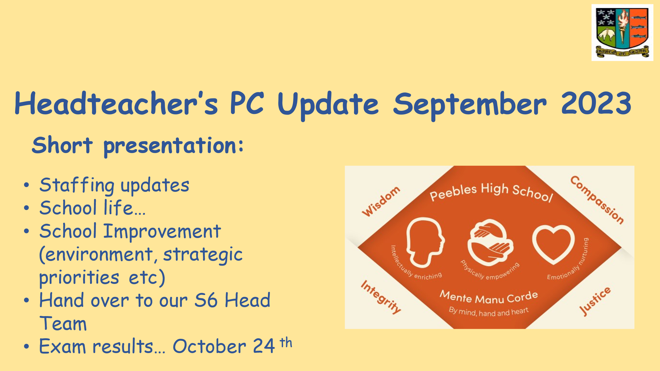

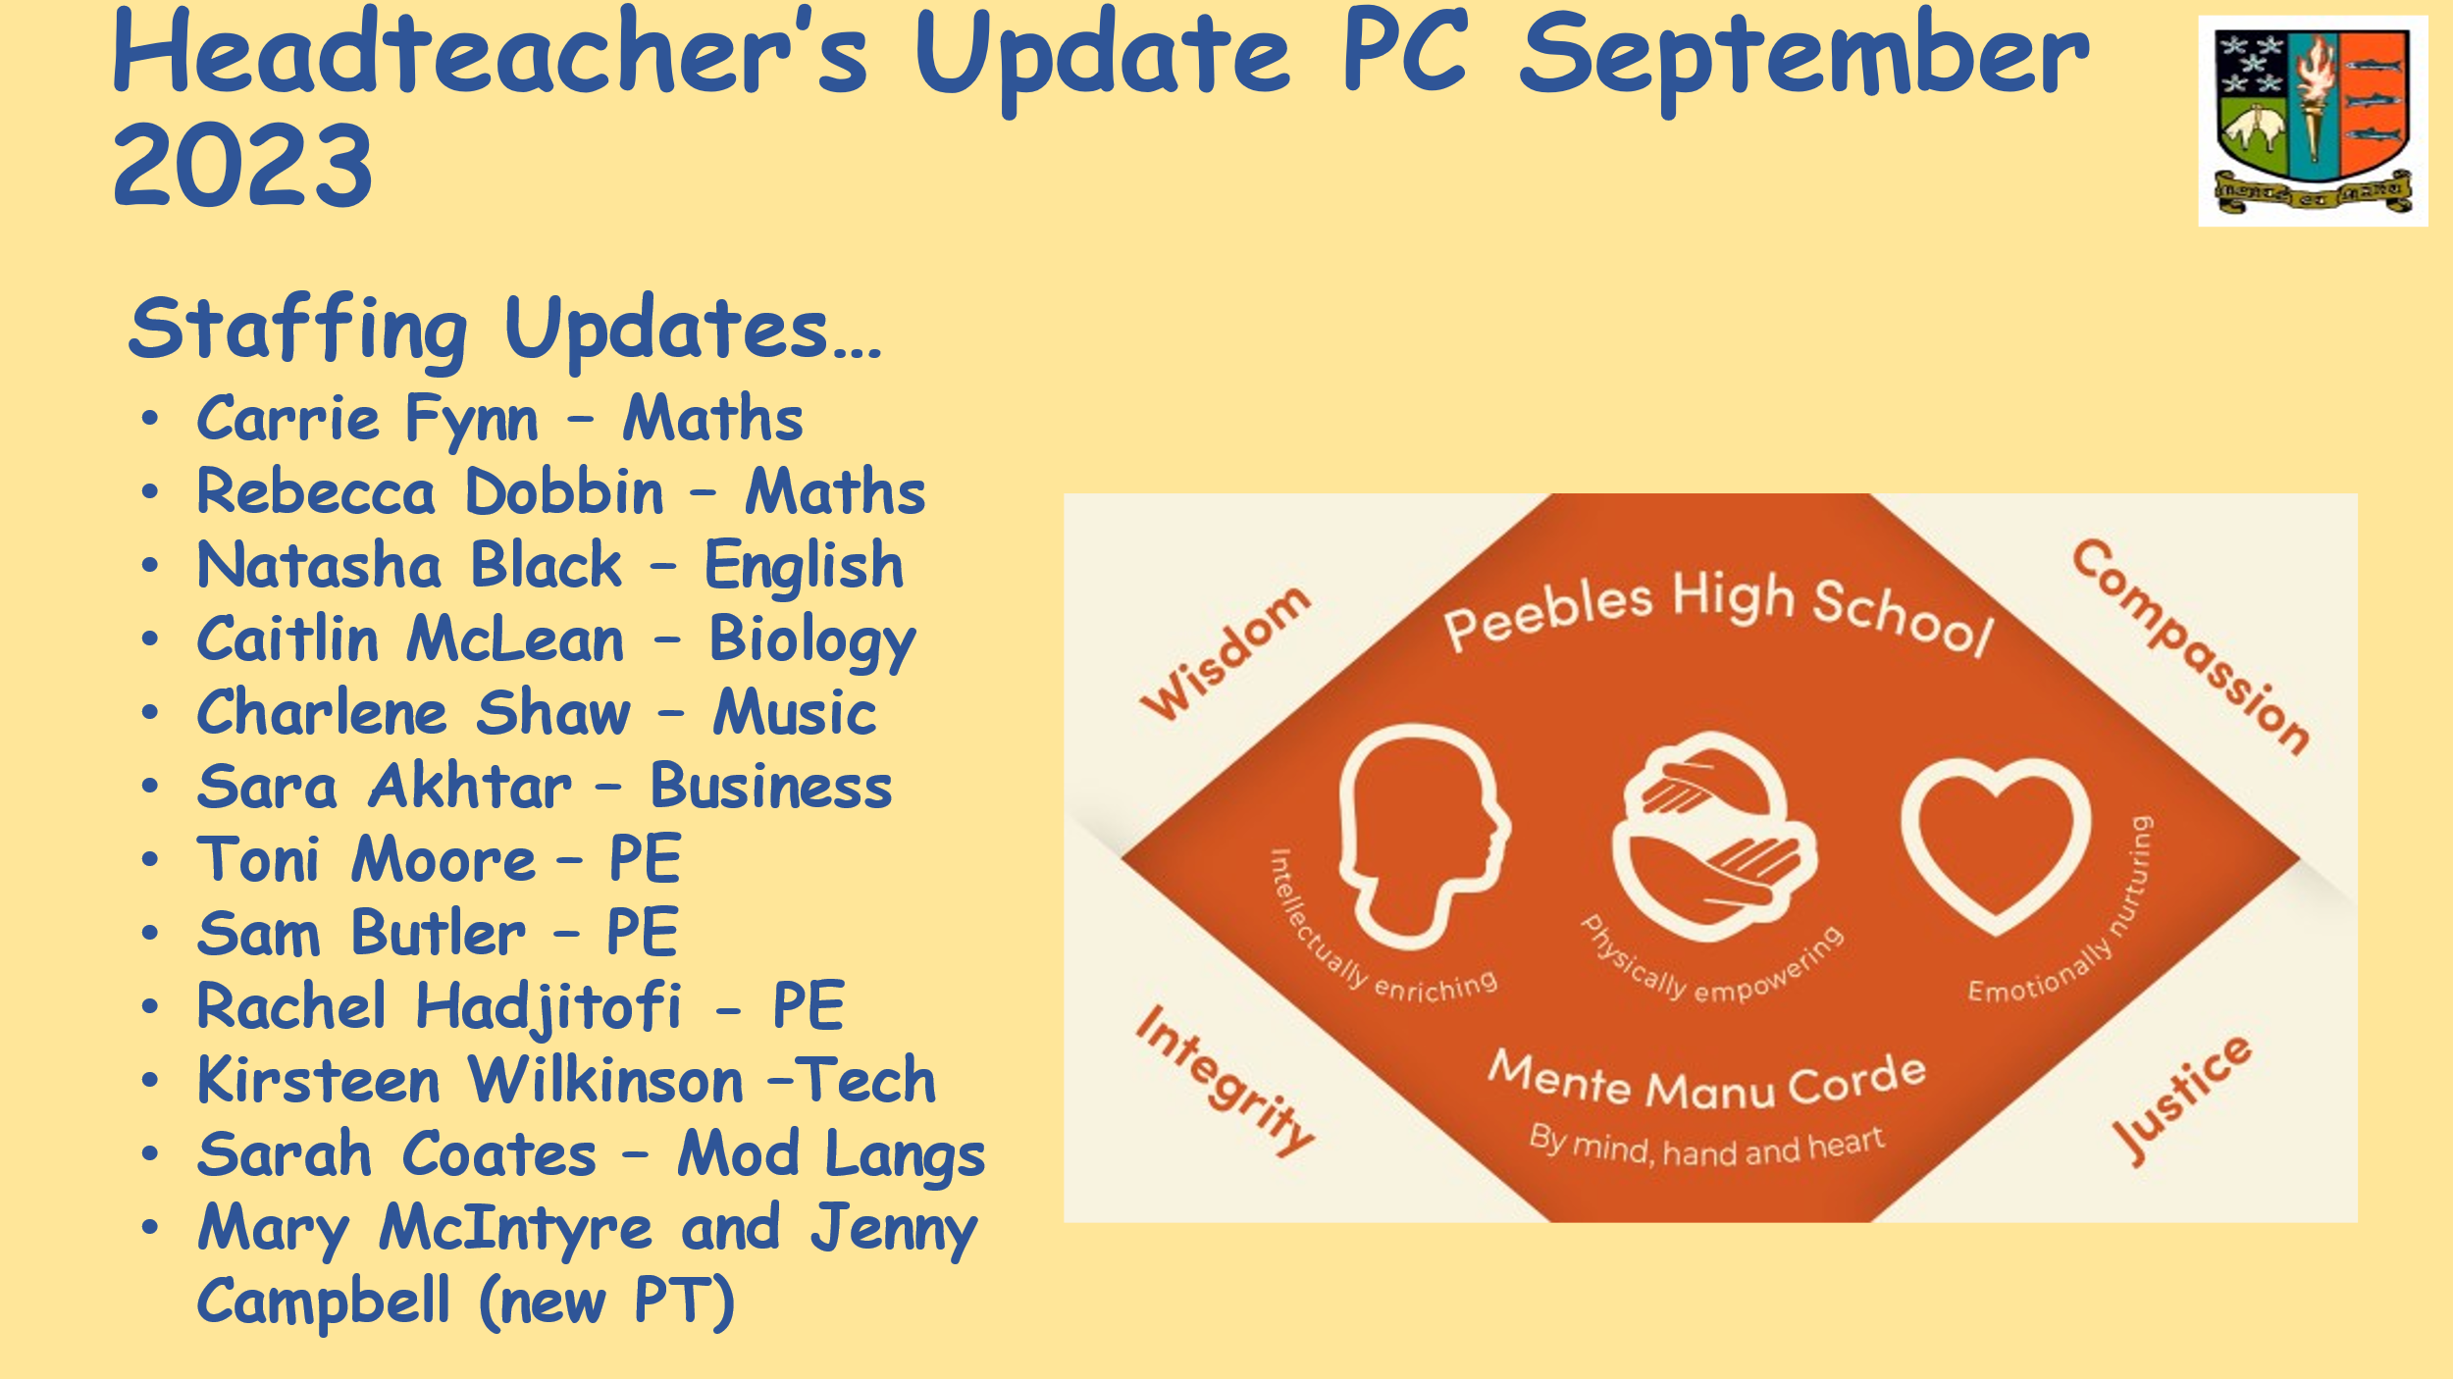
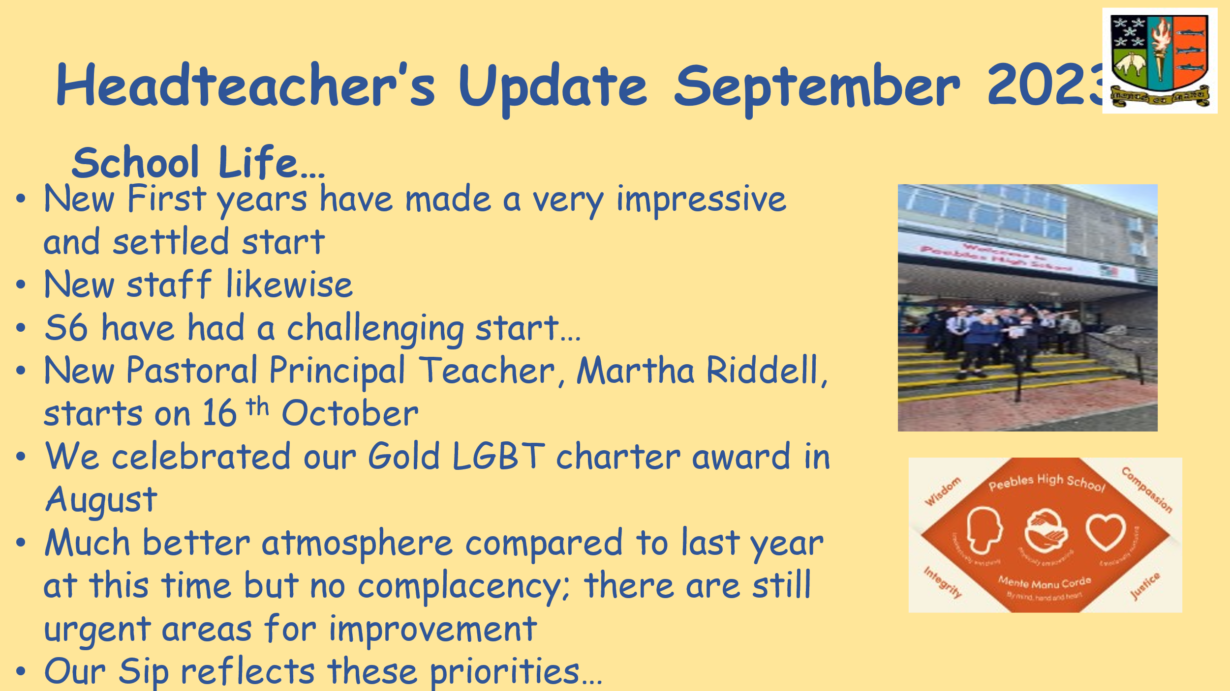
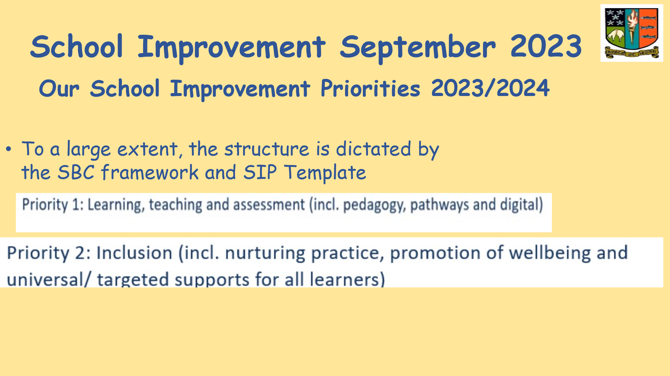
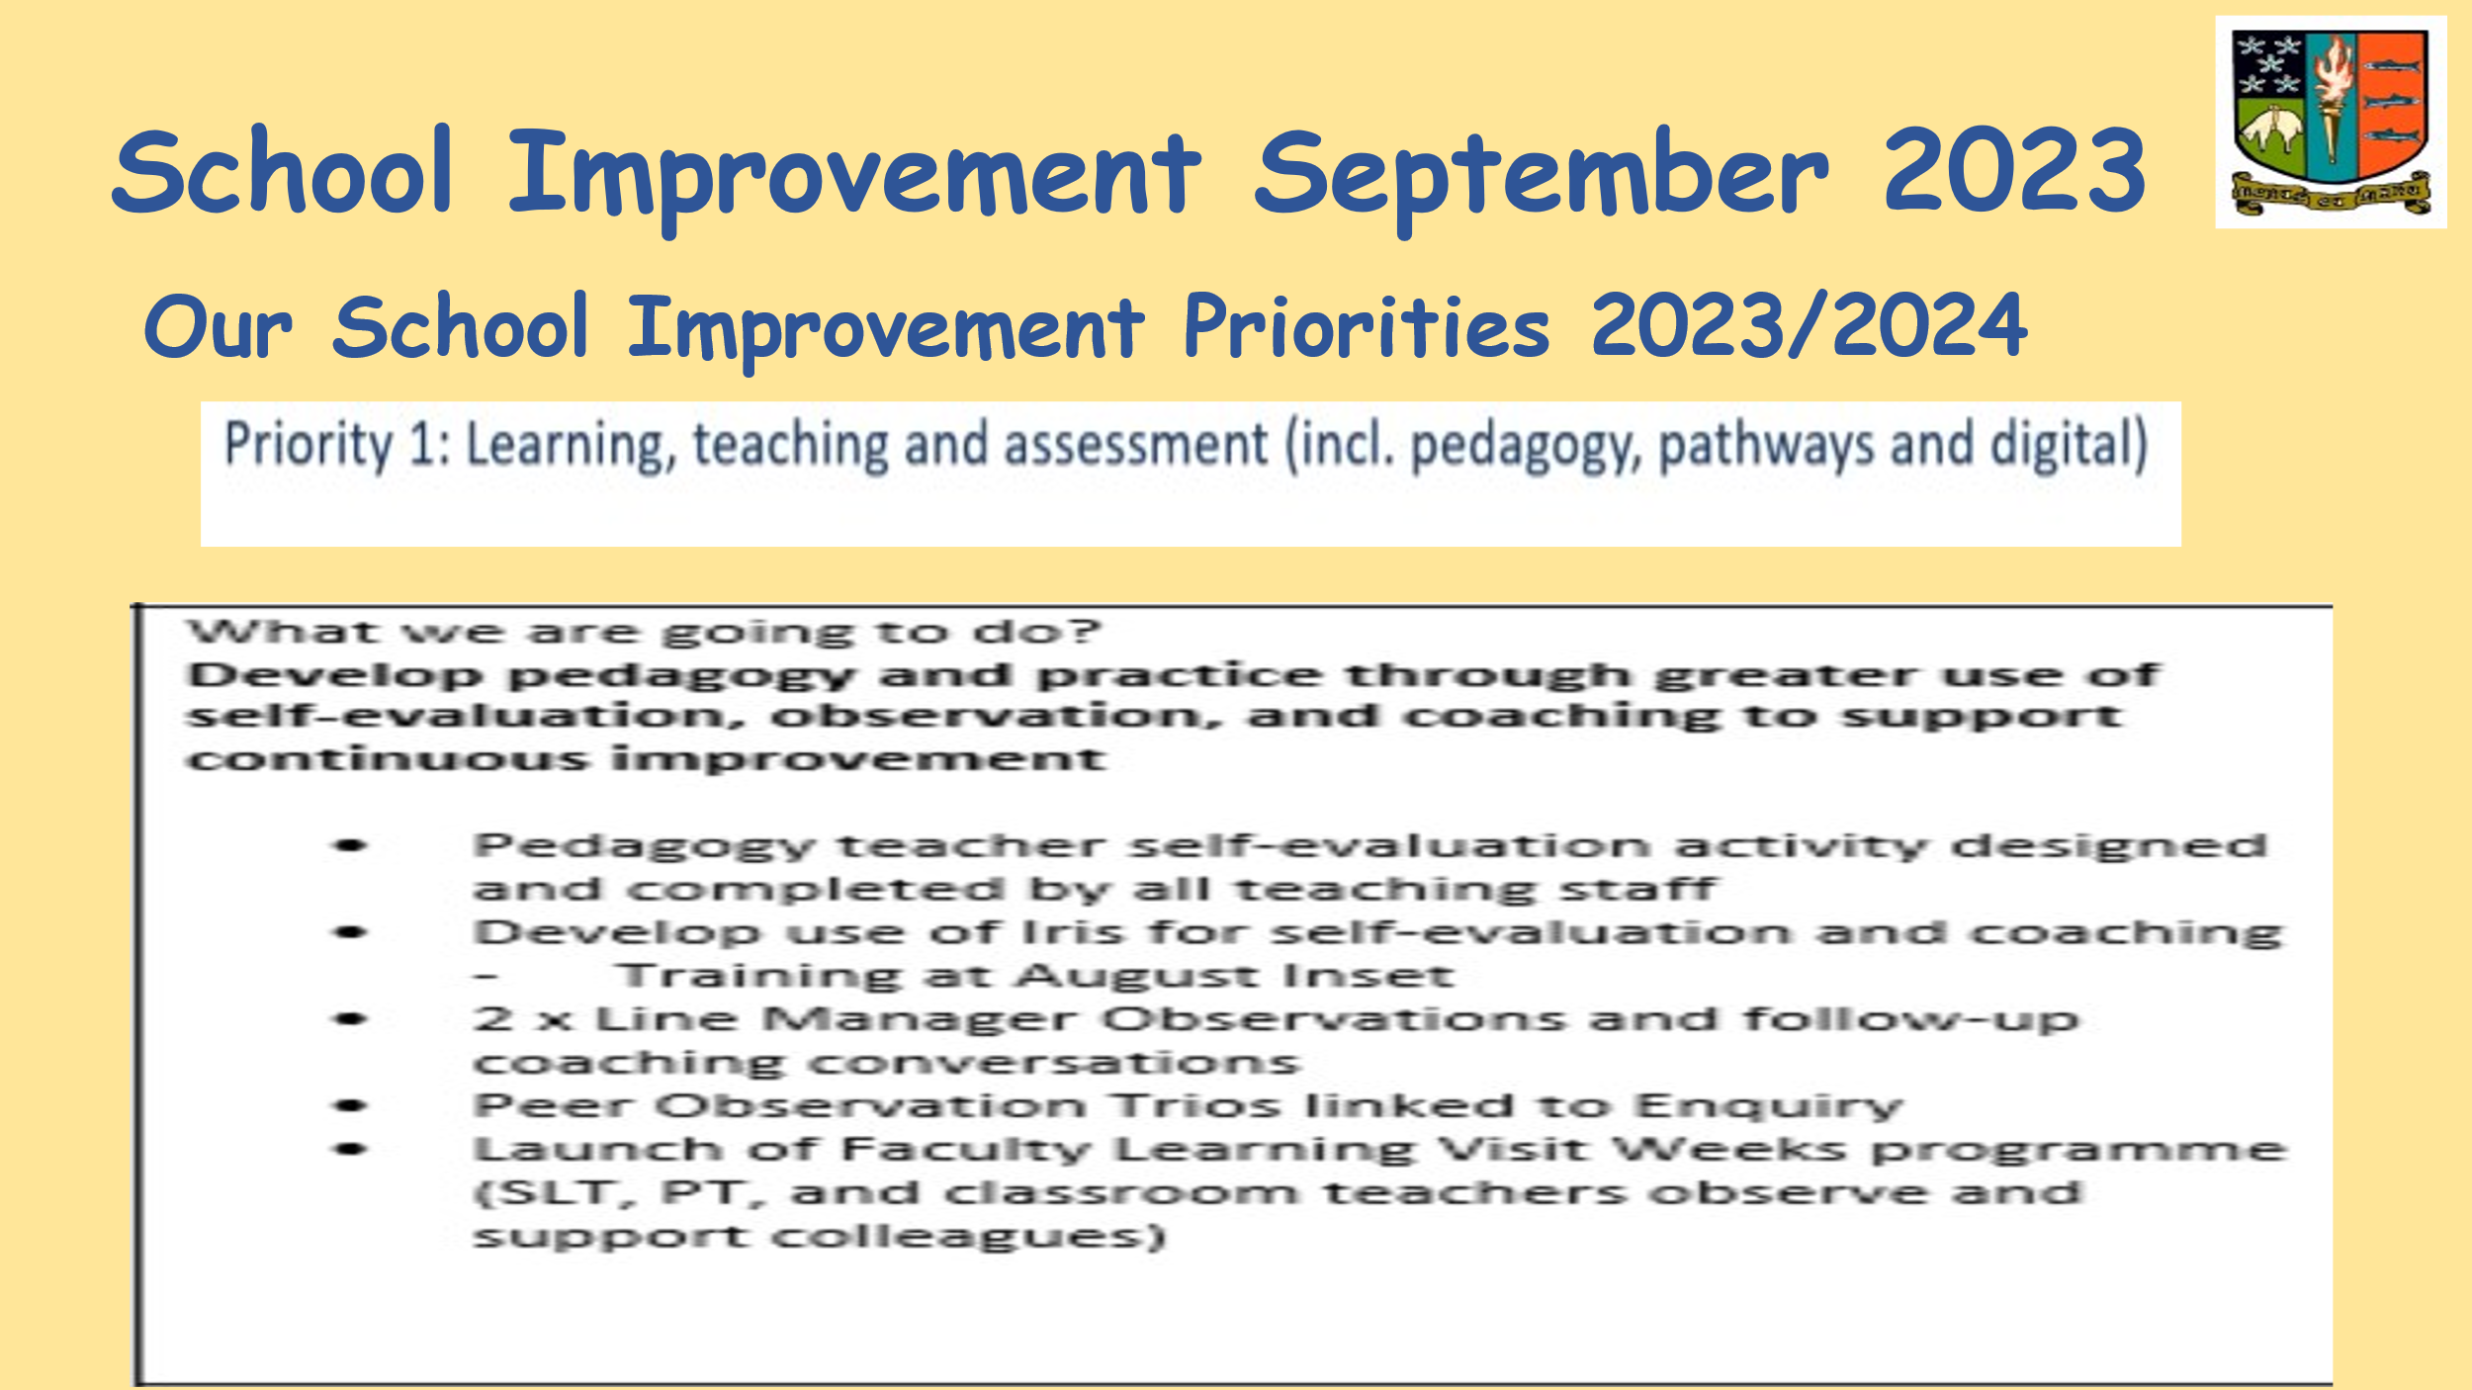
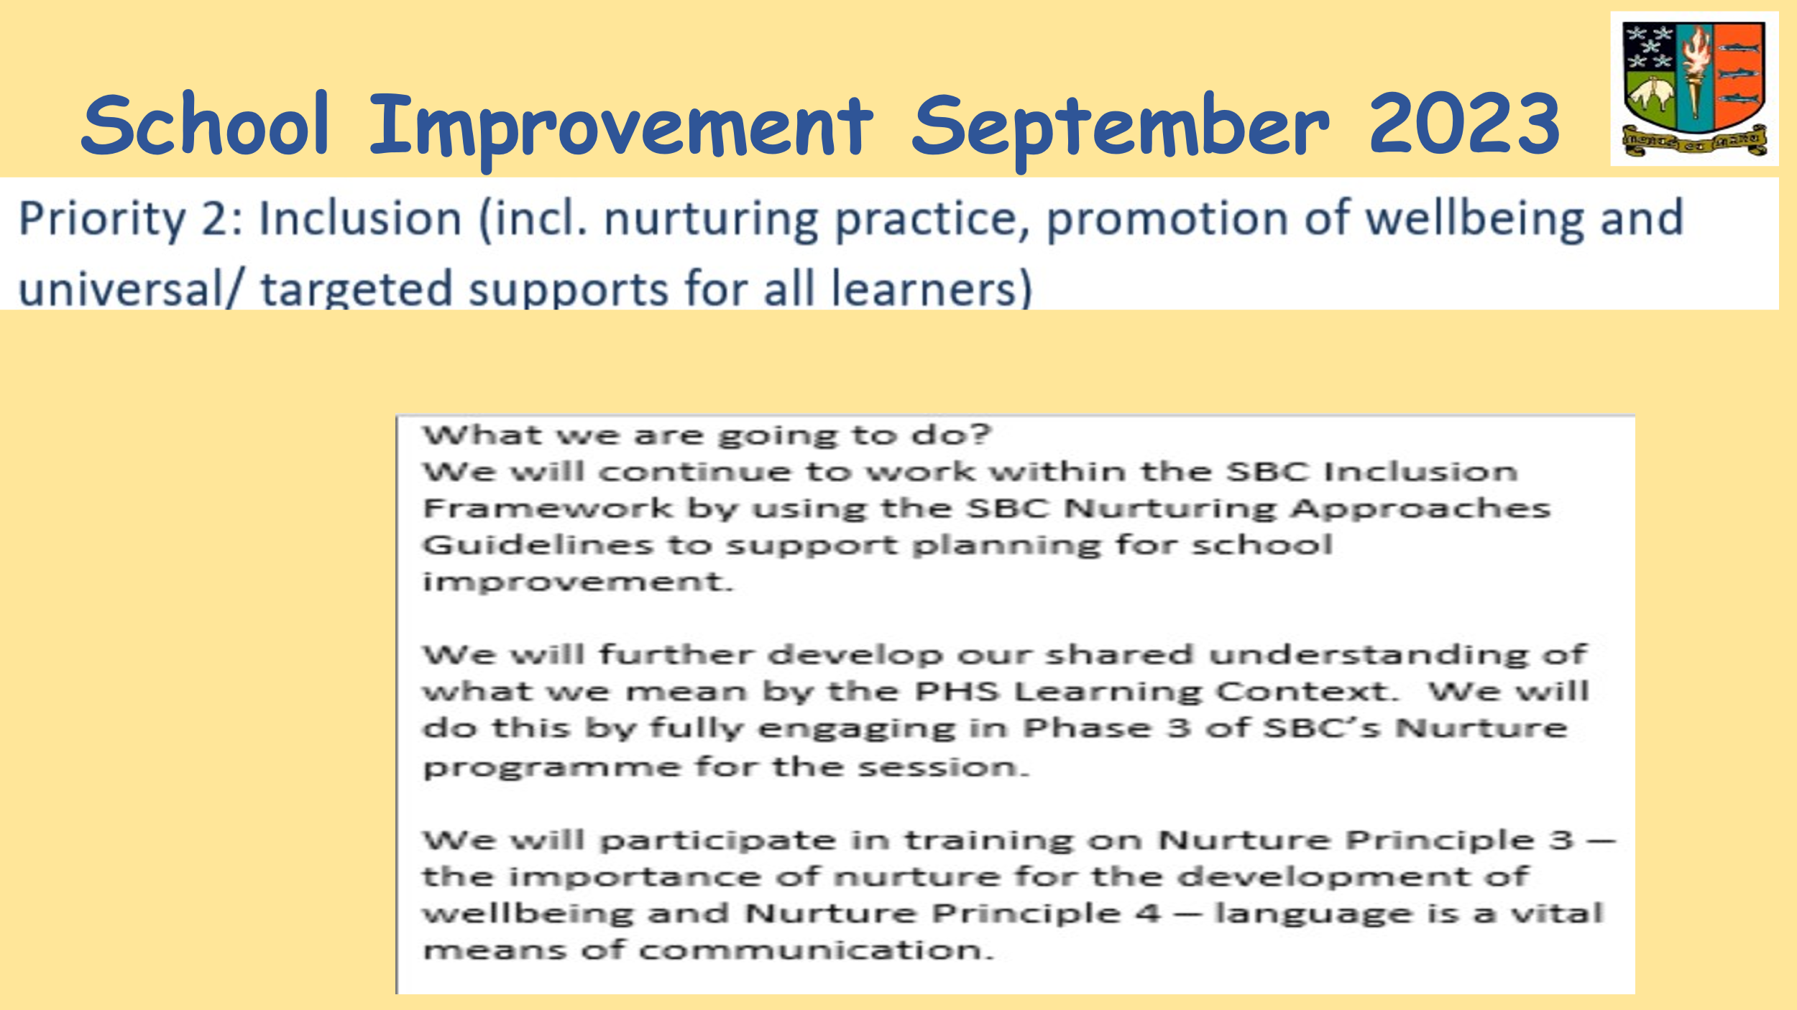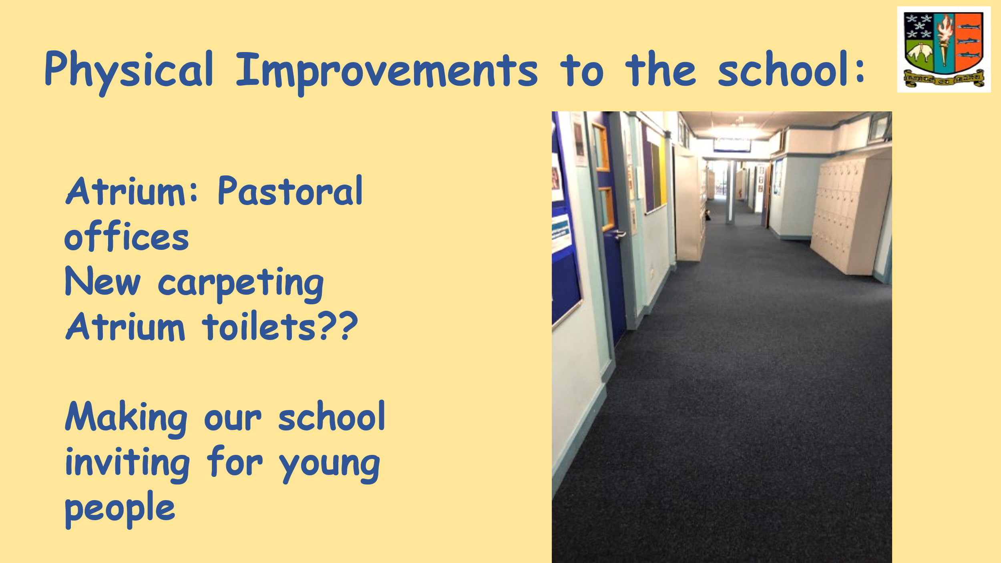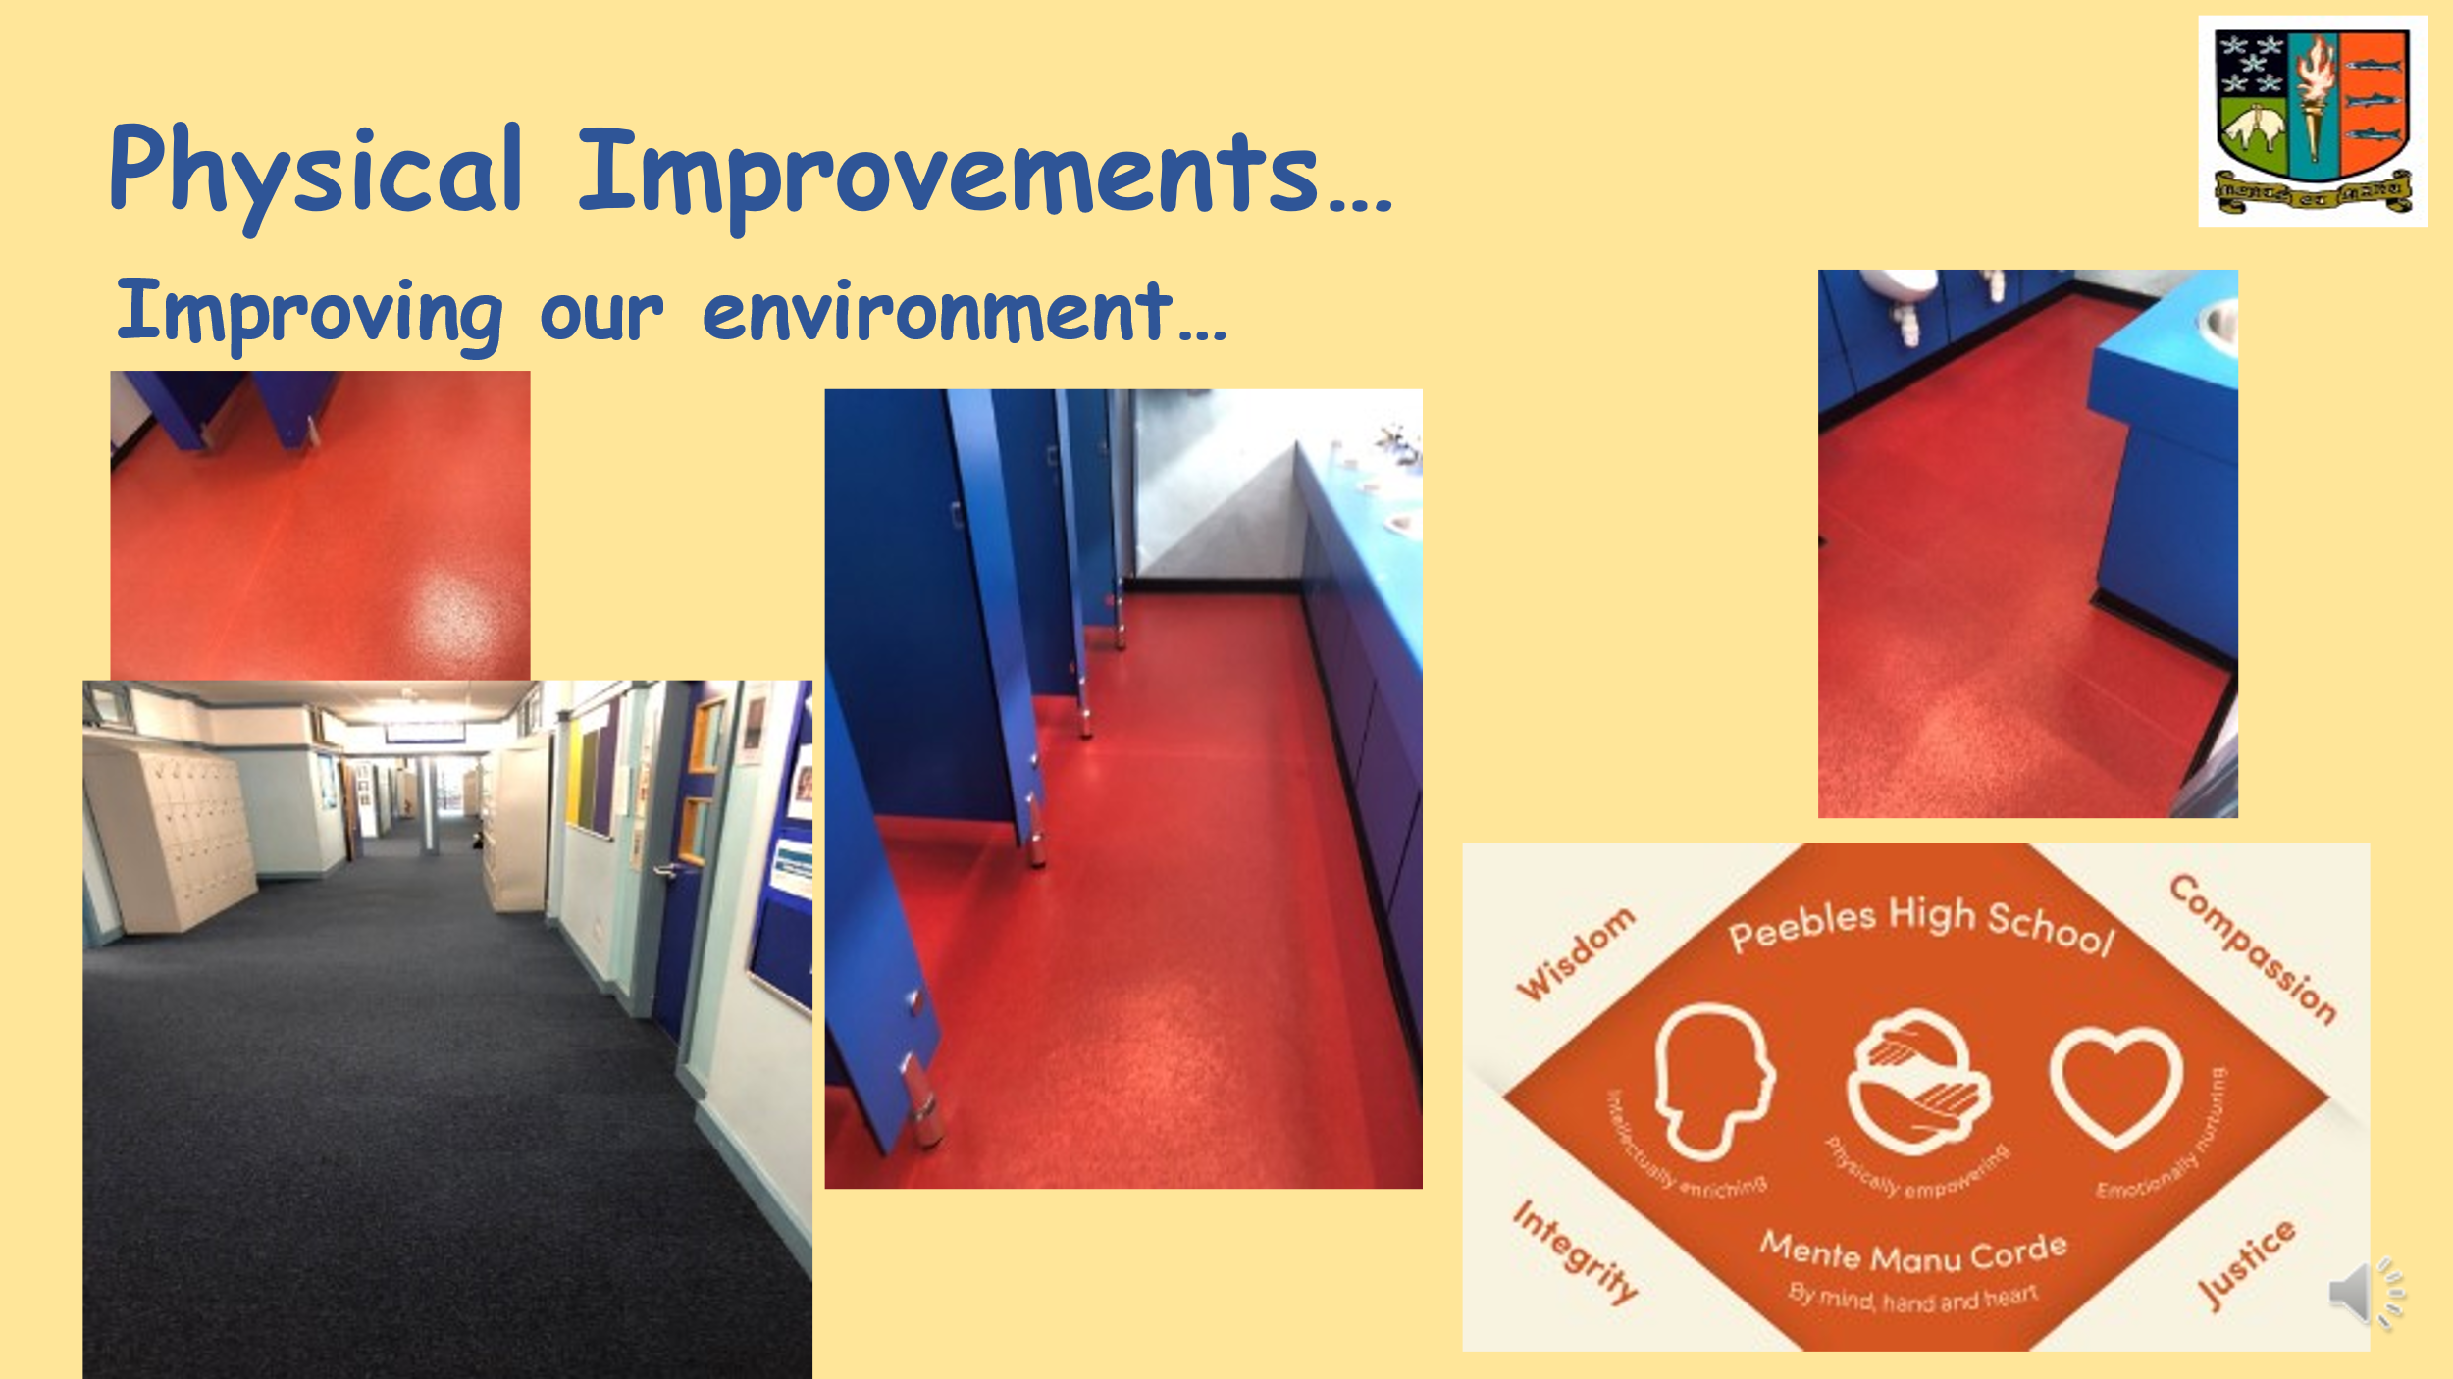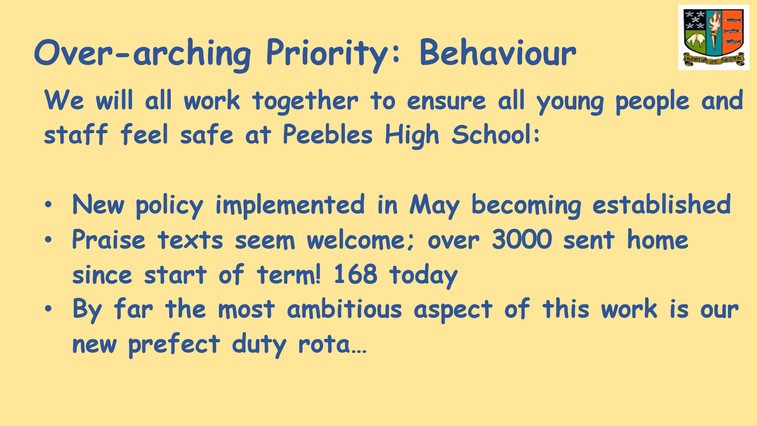
Exam Results – there will be a presentation after the October holidays, date TBC, all welcome.

S6 Presentation S6 Pupils
Head Prefects: Sam Wardlaw & Charlie Franklin -White
Deputy Head Prefects: Kayla Bisset & Hannah Begg (absent, Freya Compton standing in)
S6 Head Team spoke about the Prefect duty rota:
The Head Team meet every week with Mr McMordie – how to improve the school. S6 prefects are voted in by staff and pupils. Supported by Assistant Prefects in S5.
The Head Team explained what ‘Duty’ means – prefects and assistant prefects are an authority, to keep control of pupils and encourage good behaviour. Present in the back, front, atrium, millennium wing, sports hall and canteen at breaks and lunchtime.
It is working well, they are being listened to but of course there are issues. There is a reporting system - an online form is sent to member of SLT who act upon it. Eg – fight, abusive behaviour. Only 20 reports so far, most acted upon so working positively.
Benefits the prefects as all their hours are tracked as volunteer hours, which count towards the Saltire Award.
Sam - speaking to younger pupils, main feedback is safety element, particularly among younger year groups.
S4/5/6 not so interested as they know their way around school but working well among younger year groups.
S1 induction – prefects were introduced to them, they all wear green ties so recognisable as someone who they can trust and help out.
Freya – Faculty Ambassador Programme – S5/6 can apply for one of these leadership roles – there are a lot of roles – you don’t have to be a prefect to be a faculty ambassador. Working with particular faculty, various tasks eg keeping classroom supplies up to date, planning activities for the faculty. Help out in junior classes. Great feedback from prefects on this. Also counts towards Saltire Award as volunteer hours. Going really well. Maybe a good alternative to being a prefect, if you’re interested in a particular subject rather than being a prefect. One idea they had was creating a sense of where you are in the school, for each subject, eg display in the corridor.
Kayla – regarding study spaces – canteen, atrium, sometimes library but it is limited. Making a rota of empty classrooms this year, so always a quiet space for all year groups to do homework and study. Leadership roles – there are so many more than before. EP Buddy (enhanced provision) made a really positive impact. Languages - S3 and S4 can become Language Leaders. Faculty ambassadors have been paired with one child to sit with them to build up their confidence.
Parent Questions:
What would you like to see for study space?
A: empty classes will be good, and Prefects may supervise to ensure being used appropriately. A library would be great!
Tweed Reads – exciting project for a reading shed in the courtyard area of the Atrium. Filled with books for students to read.
Toilet use – particularly S1 pupils, are they using the toilets more?
It’s definitely improved. Prefects pop in and out of the toilets to check no crowds, being intimidating etc.
Can that be communicated better as S1s think it’s too scary to use the toilet?
One of the things we want to introduce is a Prefect in each House Time class in the morning, so we can communicate things like this.
What contingency is in place when you go on study leave?
We’ve been speaking about it. There are less students in the school then. There are also more teachers around at that time.
Do you feel they respect you and behave when asked?
Yes when they see they are not going to get away with it it discourages others from carrying on.
Extend Assistant Prefects to S4?
S4 don’t have any free periods and have new exam pressure.

The pupils were thanked for their invaluable input and welcomed back to future meetings.

New School Update
Tristan Compton introduced himself to any new parents as the PC Working Group Lead for Buildings Sub-group (New School Building), and summed up the involvement of the Group so far in the process.

3 key priority areas:
• Limited size of the new hall and implications
• Ongoing and regular engagement plan with the project team
• Existing building and impact on current pupils
Steven Renwick, SBC Project Manager gave the following update:
New 3G pitch is scheduled for completion in next couple of weeks.
School is ready to proceed to construction. Project cost is now £61M (from £46 originally). Funding approved. Formal construction contract submission tomorrow. Start date to end of September, roughly 2 year construction process. Encouraging Corporate Team at SBC to celebrate the start of construction – we will work with school (staff, pupils, Parent Council) on that. Happy to come to subsequent PC meetings to give updates as construction continues. Contractor BAM will continue in the build. They will talk through the construction process with pupils and staff.
Study space & toilets
Toilets – big improvement in the new school. Each cubicle completely enclosed and open to the corridor areas, as already done in a variety of new schools. Social spaces, small tutorial spaces for study, outwith the timetabled spaces.

Parent questions:

What is the completion date?
SR: End Sept 2025. Then commission the IT, and move over everything. Hard to give a new date but Autumn 2025.
How likely is that date to be met? Contingency?
SR: Plan in place to start, plan to see it through. Contractor has done lots of work for us before. It’s all ready for that main build. Normal contractual safeguards are in place to ensure the build is not allowed to overrun
Can financial penalties imposed on contractor if don’t meet schedule, go back into PHS?
SR: Application of any damage and any penalties will remain in project initially ie for the school and pupils, and not go back into SBC. Damages cover ongoing costs. Existing school will remain operational until new build is ready.
We have not said we will not invest in the old school. We will keep looking at requests for funds for things and making judgement calls on them.
Will there be Lockers in the new school?
SR: Not just now. Can be added in. A lot of loose furniture has still to be decided on. Lockers are not the best used in other schools.
There are no Faculty staff rooms? Why? They are a great benefit as pupils go to them to see teacher for help.
SR: No, there are staff areas but no dedicated staff bases for each faculty. CW: there are teacher bases near each faculty area which can be used - there are significantly more staff areas in the new build that we have currently. Flexible breakout spaces near each faculty area, allow for that same interaction, just not in a room that’s labelled ‘faculty base’. There are architect’s recommendations but it’s up to me and SLT to decide who goes where.
Is there a possibility of using new furniture in the old school, rather than just for day one in new school? There can be a tendency to start mistreating existing furniture, fixtures etc as coming to end of life at the school and going to be demolished.
SR: We always provide brand new furniture in a new school, if we were to put that in the existing school we’ve never done that before. CW: we’re fortunate we have wonderful pupils, I don’t think that attitude would prevail or we would tolerate that.
No S6 common room? Why not?
SR: There is no S6 common room, we haven’t delivered that in Education projects as that is not the right thing to do. There is a variety of different social spaces rather than a separate common room. Why, because they have been abused, decision taken a log time ago not to introduce common rooms. CW: we could make a decision to dedicate a space to 6th year common room as there are spaces.
Can I ask about the current school roll, the new build was based on 1400. What about impact of house building – the population is predicted to increase 30% in 10 – 12 years in Borders and Midlothian, concerned the roll will exceed 1400
CW: in 2019 prior to the fire the school roll was 1250, it is currently 1409, for the first time we have gone over 1400. Then we are looking at a decreasing roll.
SR: that’s the first I’ve heard of 30% increase in population in 10 years, our prediction is plateau then decline. The likelihood of additional houses and demographic for those houses has been factored into these projections.

As we get a larger roll, how does this affect the school – is there more funding for classrooms? At what point is the school full? We have 150 extra kids, how can we access funds to have a couple more portacabins to free up space for study, library. £10M extra for the new building but nothing has been allocated to the current building.
CW: we are tight for space, particularly intervals and lunchtime. We have 25 Ukranian children for example.
Portacabins are funded from a different part of Education budget
Mr Wilson commented that pupils have chosen to use other spaces etc Atrium, Canteen even when the LRC was dedicated study space.
Mr Reid pointed out the disproportionate disruption to pupils if you displace all classes which are currently using the LRC, for the sake of taking back the LRC.
S6 pupil made the point that students can still study in other spaces, they are not ideal but they will make do.
A parent commented that some pupils cannot ‘make do’ eg if neurodiverse
ACTION: Steven Renwick to ask Director of Education about school capacity and whether funds can be found for additional accommodation due to this increased roll.
ACTION: Parent Council will also write to Director of Education to seek a formal answer.
ACTION: Mr Reid to email Parent Council the detailed reasoning for not taking the LRC back for dedicated study space.

Tristan summed up the discussion:
There will be ongoing discussion about the main hall and the Building Sub-group will keep progressing that.
Keen to keep engaging with SBC, BAM etc on a regular basis during the build about other decisions.
Existing building – we will keep pushing for changes for our current students too.

The meeting closed at 9.15pm

Please get in touch around any of the issues raised at phspc@outlook.com
____________________________________________________________________________________

Helpful Info/Reminders

Parent Council Meeting Dates for 2023/24
Wednesday 13 September 2023 – in person
Wednesday 15 November 2023
Wednesday 24 January 2024
Wednesday 20 March 2024
Wednesday 24 April 2024
Wednesday 12 June 2024 (AGM)

Post Holders
Chair – Ellie Johnstone
Vice Chair – Tristan Compton
Secretary - Claire Barrett
Communications Officer – Dawn Johnstone
Equalities Lead - Lorraine Murray
Event Coordinator – Gillian Moran
Friends of Peebles High School SCIO representative - Eric Nightingale
Property Working Group Lead – Tristan Compton
Taskforce Coordinator – post vacant

We welcome interested parents & careers on the Parent Council as general members or working group members. We simply ask that you try to attend meetings regularly. If you would like to be an ordinary member or join a specific working group, please email your details to: phspc@outlook.com

Any parent or carer interested in supporting the Friends of PHS charity with running fundraising activities should get in touch at mailto:FriendsofPHS@outlook.com

Website: phsparents.org.uk
Facebook: PHS Parents – can contact us via Messenger
Twitter: @PHSparents @PeeblesHigh

