PHS Parent Council
AGM
6 June 2023
Via Teams
Attendees
Sarah Duncan, Chair, Parent Council
Susan Jarvis, Co Vice Chair
Ellie Johnstone, Co Vice Chair
Claire Barrett, Secretary
Judith Ackerman, Communications Lead
Tristan Compton, Property Working Group Lead
Eric Nightingale, Friends of PHS SCIO representative
David Flynn, Treasurer, Friends of PHS
Campbell Wilson, Headteacher
c.23 parents attended

Welcome & Overview
The Chair welcomed everyone to the meeting and gave a reminder of the various ways parents can support fundraising for the school: Corporate support match funding
Easy fundraising
Attendees were also reminded of the various ways the Parent Council engages with parents, via the website: https://phsparents.org.uk/ where all meeting papers and minutes are posted, and social media channels Twitter: @PHSparents and Facebook page: PHS Parents.

The Chair gave an overview of Parental Engagement at PHS:
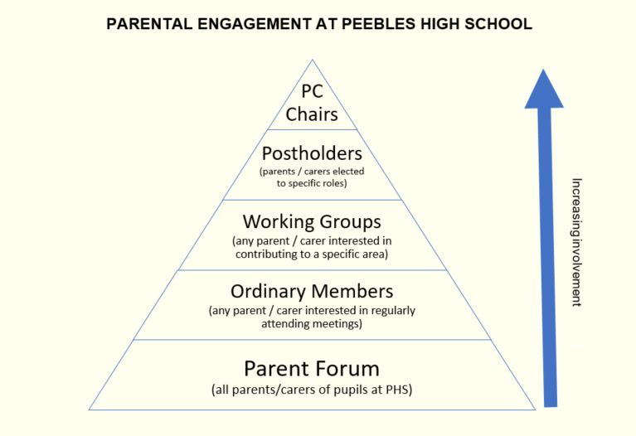
The Minutes from last year’s AGM were agreed. Recent Actions were updated as follows:
Subject choices - notify parents once choices confirmed
Closed - not achieved and feedback provided
Investigate data on class cover and report back on process
Closed – Mr Wilson will provide an update in his report (see below)
Permission to carry forward DSM for building improvements
Ongoing – Mr Wilson meeting with Justin Sinclair (SBC Chief Education Officer) tomorrow
Solution for keeping the daily bulletin up to date on the website
Complete and being monitored
Catering provision discussions with SBC
Closed - Presentation from SBC catering to all Parent Council Chairs in May, next steps to be discussed with Secondary Chair group. Parent Council will share the catering strategy with the parent forum.

Chair’s Annual Report
Challenges:
- Delay in SBC confirming budget impacted recruitment timelines leading to a school underspend
- Lack of progress with improvements to current building
- Ongoing concerns around behaviour and communication
- General feeling among parent forum that our concerns haven’t been taken seriously in recent years and frustration at perceived lack of partnership

Successes:
- Supported recruitment of new Deputes and Pastoral
- Supported delivery of the Fresher’s Fair and Careers Fair
- Advocated for improvements to new school plans
- Supported SBC school review process
- Supported projects across the school with funding from charity
- Presented parent improvement priorities to the school

Additional Activities:
- Supported various school online parent sessions
- Secondary PC Chairs lobbying for additional mental health support for pupils
- Parent Experience Survey completed and results shared
- Uniform Review carried out
- Provided support for DYW Steering Group, Equalities Working Group and Eco-Committee

The Chair thanked members of the Parent Council and Forum for their support throughout the year.

Friends of Peebles High School Charity – Update on behalf of the Trustees for the period 1st August 2022 to date
The Chair outlined the structure of the FoPHS: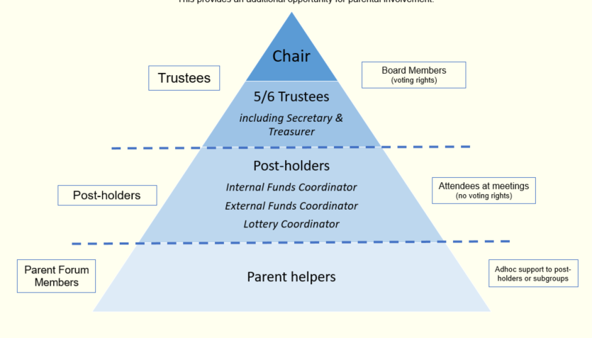
Eric Nightingale, FoPHS Chair & Trustee provided the following update:

A successful year whereby income has very closely mapped the value of outgoings, particularly in respect of the level of donations to PHS in response to the bids process. Firstly, the numbers:

Receipts:
PHS Lottery Donations |  |  |  | 2,719.36
School Events (Concerts/Raffles) |  |  |  | 985.88
Matched Funding Donation |  |  |  | 500.00
Easy Fundraising |  |  |  | 143.87
Amazon Smile |  |  |  | 36.91
 |  |  |  | 4,386.02
Payments:
PHS Donations
2021/22 Bids |  |  | -1,420.08
2022/23 Bids |  |  | -1,779.44
Iris Camera donation |  |  | -2,000.00 | -5,199.52
Miscellaneous |  |  |  | -239.00
Income less Expenditure |  |  |  | -1,052.50
Cash reserves at 01/08/2022 |  |  |  | 16,064.28
Cash reserves at 06/06/2023 |  |  |  | 15,011.78
Less: Approved Bids awaiting payment
2021/22 Bids |  |  | -138.15
2022/23 Bids |  |  | -2,213.00 | -2,351.15
Net Cash Balance |  |  |  | 12,660.63

Highlights:
- The PHS Lottery continued to perform extremely well despite the challenging economic pressures The net income of £2,719 compared favourably with last year’s equivalent period figure of £2,209. Note the June draw is still to be reflected within these results. Our gratitude is therefore extended to all members both old and new.
- Thanks go to David Flynn, our Treasurer, not only for administration of the Lottery and maintenance of the charity’s accounting records etc. but for once again securing £500 of matched funding from his employer.
- Post covid has seem a welcome return of school events which provided almost £1,000 net of expenses. So again, thank you to all organisers, helpers and to everyone who contributed by donating raffle prizes and purchasing refreshments and tickets.
- PHS Donations

  - 2021/2022 included £1,000 towards school improvements identified by the pupil parliament.
  - 2022/2023 included £1,000 for training of 60 pupil leaders, and £779 for 4 speakers and lockable notice boards for Drama & Expressive Arts classes.
  - Yet to be paid out for 2022/2023 is £1,110 to cover the cost of Duke of Edinburgh outdoor certificate training for 6 teachers & parents. Plus £1,103 to cover the purchase of 25 stylus pens for Expressive Arts.
- 2023/2024 Bids
  - The bids process is already open with a closing date of September 2023. Information on any recently submitted bids will receive consideration by the Trustees at the meeting scheduled for next week.
- Pipeline Funding Opportunities
  - Production of a promotional bag is in the final stages of consideration.
  - A car boot sale, originally planned for Mid-June will be rescheduled for Aug/Sept in response to expressed interest.
- Finally:
  - Will all parents please let us now at friendsofPHS@outlook.com if they are willing to engage in any fundraising activities and particularly if they are eligible to benefit from any employer matched funding opportunities.
  - Please do take advance of charitable cashback available by registering your support of Friends of Peebles High School at: https://www.easyfundraising.org.uk
  - Should anyone have ideas for fund raising opportunities or knowledge of charitable funding schemes that may be relevant to the school again please let us know.
  - Any Questions ?

Equalities Working Group
Dawn Johnstone provided the following update (in Lorraine Murray’s absence) on the re-writing of the school’s Respect Policy
- The subgroup were involved in rewriting the schools Respect Policy to ensure it was inclusive, addressed LGBT and UNCRC issues.
- The policy name has been changed to the "Anti-bullying policy - creating a culture of respect". This was after group discussion and also feedback from students at PHS.
- The intention is to gain a gold award from Youth Scotland LGBT (PHS is currently Silver award holders)
- There was some email liaison with the school representatives who offered an update on their progress
- The equalities group approached this with an awareness of recent bullying surveys at PHS suggesting there was a need for awareness to support anti-bullying measures.
- The policy was produced in an updated format which was designed to be more inclusive:
- the wording was changed to incorporate reference to 'a school community' - parents, staff, students
- a user-friendly format that addressed the needs of readers experiencing dyslexia (text size, background colour, font)
- *preparing a text reader-friendly version
- incorporating different media to present information (so it wasn't too long didn't read)
- Each subgroup member re-wrote their section (parents, students, staff) with this in mind.
- The section for students was created by a youth group in Peebles (led by Tyne) and was sent to PHS (student parliament) for feedback but not had confirmation if any received. It was an excellent presentation by youth club members (students of PHS) and it has been included as a link within the main rewrite of the policy (it contains some video links and is more interesting and dynamic). Interestingly (and rather ironically) the youth members who created it wanted to remain anonymous for fear of being bullied!
- The new policy is to be made available via the PHS website when it is finalised.
Outstanding issues
- The subgroup and PHS are at an impasse on whether there should be the option for anonymous reporting of bullying. The subgroup suggested that while this could not be acted upon as per the policy outline, a collection of data would provide insight and information into key areas/hotspots that needed attention.
- The subgroup had some concerns about GDPR and the collection and storage of personal data (eg using the current bullying reporting system on the website that collects data) - as yet no clear confirmation that this meets GDPR standards. When school conducts surveys about anti-bullying - where is the text that confirms use and storage of data? When students/staff/parents report bullying incidents - same issue re GDPR unless anonymous (PHS uses SEEMiS but when collecting data there needs to be acknowledgement by user that data is safe/protected and complies with GDPR standards (eg if a child is using their glow account, they can be identified when taking part in a survey)
- The subgroup also offered PHS the opportunity to apply for parent council funding for restorative practice training for students and staff (possibly parents too?) in order to give them the skill base for defusing potential bullying situations. No progress on this. Subgroup suggested that attendees could mentor 2 others in order to rollout awareness of practice.
- Podcast - the intention is for the policy to be recorded as a podcast (school can upload to website) so that parents can listen to this (rather than read - perhaps more uptake re busy schedules or accommodate issues with a text format). This will be created once policy finalised.
- School poster - the intention (once policy finalised) is to produce a simple poster, highlighting the policy and student friendly version using a QR code so students can scan and access it via their technology.
- PHS was also working on the Positive Relationships policy and Social Dance policy to be more inclusive and this was to be shared with our subgroup - but nothing has been received as yet.
One of the aims for the gold award was that "All teaching staff will attend a workshop and complete four LGBT Scotland training modules and will feel confident in their responsibility to support LGBTQ+ young people." At present we are unsure if this has taken place. It might make sense to widen this action to include all staff (admin/reception) who are at the forefront of dealing with requests from staff, students and parents?

New Build Working Group
Tristan Compton gave an update on the work the group has carried out this year:
Major activity since the October SBC presentation of the new school building plans. Lots of positive feedback and some key themes of specific concerns: school hall capacity, social spaces & catering, is school big enough for roll, open- plan classrooms and impact on learning & teaching. Key topics targetted: the open plan design and the assembly hall. SBC not really willing to consider another redesign. Tried to engage with SBC and wider community to look at other improvements. Spoke to SBC councillors, press, Directors of SBC, community councils, primary parent councils. Thank you to the Group – lots of work was undertaken.
In February 2023 SBC undertook community events with revised plans showing fewer open plan classrooms and a much larger hall, dedicated space – real changes. Overall, a positive story from Working Group this year.
Timeframe update: PE Block was due to be completed in April, this will now be August 2023. New school follows that – likely work start in August then 2 year construction - therefore building complete late 2025, then demolition of the old buildings in 2026.
Regarding the poor condition of the existing buildings, which feeds into lack of respect for school, poor behaviour, etc. Good news – new carpets will be fitted in the Millennium Wing over the summer holidays, and other cosmetic work. Also asking for budget for other parts of the building and hopeful for progress on this too. [see Mr Wilson’s update below for more on this]
Having established changes in the design, we’re now onto how we use the school, how we get the best out of the new building.
Tristan thanked the 10 members of the New Build Working Group who have put in a lot of work – some are stepping down so keen to welcome new members to the group. If any parent is interested please contact mailto:newbuilding@phsparents.org.uk

Headteacher Update Campbell Wilson
Our School Improvement Plan (SIP) changed after the SBC review - there has been a deterioration in behaviour in the community, and a spike in pupils not feeling safe in school.

Priority 1: Curriculum Audit

Progress:
Departments have reviewed their Broad General Education (BGE) Experiences & Outcomes (E’s & O’s) and benchmarks. Completion of this was against the new school vision to ensure our BGE curriculum (S1, 2, 3) is Intellectually Enriching, Physically Empowering and Emotionally Nurturing as well as fully understanding our BGE coverage. This work has been concluded within each faculty and will inform Faculty Plans next session.

Next Steps:
Alasdair Reid will collate and analyse the audit and use this to create a refreshed Curriculum Rationale.

Priority 2: Learning & Teaching

Staff co-created a lesson evaluation tool which is supporting improvements in the quality of teaching. Our in-house professional learning programme has been enhanced with more research-informed practice sessions through our professional reading and Spotlight Career Long Professional Learning (CLPL) sessions, and we have re-designed and relaunched our staff pedagogy newsletter to ensure regular sharing of practice across the school. The topic of each issue is aligned to key areas for improvement in teaching and learning – Dual Coding (to support differentiation), Feedback and Next Steps, Differentiation, Questioning, Behaviour Management. The Teaching and Learning working group have designed an extensive professional learning sharing OneNote, which is ready to launch to the whole staff body in August, and we have redesigned quality improvement practices around teacher self-evaluation, quality improvement observations and professional enquiry for use next session. The Developing the Young Workforce (DYW) working group, under the leadership of Mrs Boyd, are finalising their work on skills and agreeing a skills framework which will support staff to better signpost the transferable skills that our young people are gaining through our curriculum and make our young people better at articulating their own skills, a crucial way that we can support them for moving into life beyond school.

Priority 3: Ensuring Wellbeing and Inclusion:

Progress: all staff have undertaken Equally Safe at School (ESAS) training and are better aware of gender-based violence in all its guises. We are submitting our portfolio of progress on LGBT inclusion on 9th June and hope to be awarded our Gold charter status before the summer.

Priority 4: Reporting to parents: our aim this session was to pilot new approaches in reporting to parents before devising an improved and enhanced model for the session just started
Progress:
After a whole staff training session in August 2022, Showbie was successfully piloted in various guises (as a method of sharing full reports with the whole of S2 in May; as a method for sharing Timetables with all of S1 last week and for giving feedback on assessments and next steps for learning across various subjects and year groups)

Next Steps: Showbie will form part of our formal reporting to parents this session. Every child in every subject at every level will receive feedback and next steps for learning in at least one key assessment per class they are in over the course of the year. This is on top of the normal trackers and full reports.

In the Senior Phase, all prelim feedback will be via Showbie.

Calendar for reporting will be much more purpose-focussed with Newsletters highlighting the purpose of reports in advance.

Priorities for next session and responding to Parental Priorities in our next SIP:

Parents asked that this session we consider prelims in December rather than January. Jeremy Lee has already carried out an extensive consultation with all faculties on this point and we will be operating a split prelim diet this session with several subjects, including English and Maths running their prelims in December. Most content heavy subjects: social subjects and sciences will take place in late January or early February. Mr Lee has devised an innovative split study leave model to accommodate this parental request. Our calendar for the session will be shared before the summer holidays.

Parents also expressed their desire for the school to closely monitor behaviour and ensure that young people are feeling safe throughout the session. For this reason, and all other evidence we have gathered, Behaviour will be our number one priority this session as we implement our new policy, praise text messages and staff training by internationally renowned behaviour expert, Bill Rogers, working to train all of our staff at the October Inset day.

Timetables shared sooner. After completing his first PHS timetable this year, Mr Reid believes that all timetables can be shared sooner next year and that Showbie is the most efficient method to assure consistency for all families. After reserve choices are used, satisfaction rates this year were 100% for our S2s and 98% for the S4/5/6s.

Communication – we will be devising a new parental communication strategy this month. Please volunteer to be part of this short life working group if you want to see our communication with parents improve and you have some capacity this month to join Mrs Mooney in devising a parental communication strategy. Please email phspc@outlook.com

Actions for me from last Parent Council meeting:

- Investigate data held on class teacher cover and report back on how the school will avoid the same class being covered by non-subject teachers frequently: I carried out an investigation and it is clear that this is a particular issue in Maths. We have recruited an extra Maths teacher to alleviate the issue but it will remain the case that it is not always possible to provide subject specialist cover in the face of staff absence. Business Manager has been instructed to always use specialist cover whenever it is available. Staff attendance markedly better since Easter and almost back to pre-Covid levels

- Permission to be sought from SBC to carry forward some DSM underspend for improvement works in summer holidays: still awaiting permission. Have received confirmation I can ringfence up to £25k - seeking someone to work with Mr Lee & Gareth Smith to do full walk round of the school to decide where these improvements should be made.

Q&A

Advanced Maths Mechanics – that subject has been dropped although still on school website – my son thought over half of class wanted to do this subject
CW: I found out about this today and will go back to Maths dept tomorrow on this as there are other pupils interested . Update – this course will be run next year.

Re choices and timetabling, “after reserve choices are used, satisfaction rates this year were 100% for S2s and 98% for the S4/5/6s”.What is the satisfaction percentage before reserves?
We use Timetabler software to generate the percentage and it doesn’t generate the percentage before reserves.

Action: Mr Wilson to try and source figure on how many pupils get all first choices without reserve

Re the £25k ringfenced for cosmetic upgrades – is this in addition to the carpeting (£13k)?
CW: Yes, it is in addition to the carpeting

Could senior pupils be included in the walk around, and staff?
Yes, absolutely.

Comments Re Cover teachers:
Cover teachers - can this be spread evenly over all classes so that it is not one class that bears the burden of not having a subject teacher. Eg in maths there are multiple classes at any one time so it is not fair if it is one class that consistently has no cover.
CW: Maths is a pinch point subject nationally, and in Peebles. If I have Maths teacher off it’s harder to get a maths specialist to cover as they’re already in short supply.
This can happen in any subject – however it tends to be easier to get an English supply. There is not a single Maths supply teacher in SBC in Secondary.

Nominations for Parent Council 2023/24
The following posts were proposed and agreed for next session:

Role & Nomination | Proposed | Seconded
Chair – Ellie Johnstone | Sarah Duncan | Claire Barrett
Vice Chair – Tristan Compton | Susan Jarvis | Eric Nightingale
Secretary – Claire Barrett | Ellie Johnstone | Lorraine Murray
Communications Officer – Dawn Johnstone | Judith Ackerman | Sarah Duncan
Equalities Working Group Lead – Lorraine Murray | Claire Barrett | Judith Ackerman
New Build Working Group – Tristan Compton | Eric Nightingale | Susan Jarvis
Event Coordinator – Gillian Moran | Elodie Sellar | Dee Hollingsbee
Taskforce Coordinator – Vacancy | No nominations received
Friends of PHS Representative – Eric Nightingale | Tristan Compton | Ellie Johnstone

Susan Jarvis thanked Sarah Duncan for Chairing the Parent Council for the last 2 years, highlighting the huge success of the Auction in 2019 raising £10k, working with DYW, the Careers Fairs, opening up positive outcomes for all young people, interacting with PEF, and at a challenging time, coming out of Covid, working on the new building, the current building, the SBC reviews, all of the work with the Charity, interacting with other Council Chairs across the Borders, and influencing SBC policy and action. Thank you for contribution and support, for parents.

Sarah (Chair) thanked Susan for her kind words saying it was a privilege to chair the group, but delighted to be handing over to Ellie Johnstone and others to take forward.

Any Other Business/Q&A
Re the uniform review – my child is asking to wear different shoes, different jumper as other pupils are. Told child would get a demerit but not my experience of other parents/children wearing different things.
CW: Some demerits are issued for pupils not in uniform - a weekly report goes to pastoral staff and they decide which families to contact. The uniform has not changed yet – and it will not be a significant change, just more flexibility. We will notify in June and implement from August. Anything you currently have, won’t be wasted. One thing still debated – black footwear – new policy: entirely black, or mostly black? A quick poll on the call showed 73% were in favour of mostly black.

If I email the school, when should they reply?
CW: Plea for volunteers for communications strategy. We give 72 hours should expect response internally, I think we should expect the same but please assist with that strategy.
The Chair suggested you could call up if after a week, to chase up.

I've had questions from S5 parents - their children have study periods for the first time. They are not allowed to leave school during study periods at the moment - will parental consent be required for them to leave school, and sign out as they go?
CW: that is a privilege for S6 only. We’ll be meeting S6 this week to discuss this and give out home study agreements.
Action: Mr Wilson agreed to send out a communication to S5 parents to clarify the position on study leave.
The meeting closed at 20.30
Please get in touch if you wish to discuss any of the issues raised or any other issue by email: phspc@outlook.com

____________________________________________________________________________________

Helpful Info/Reminders
Post Holders
Chair – Ellie Johnstone
Vice Chair – Tristan Compton
Secretary – Claire Barrett
Communications Officer – Dawn Johnstone
Equalities Working Group Lead – Lorraine Murray
New Build Working Group – Tristan Compton
Event Coordinator – Gillian Moran
Taskforce Coordinator – Vacancy
Friends of PHS Representative – Eric Nightingale

We welcome interested parents & carers on the Parent Council as general members or working group members. We simply ask that you try to attend meetings regularly. If you would like to be considered an ordinary member or join a specific working group, please email your details to: phspc@outlook.com

Any parent or carer interested in supporting the Friends of PHS charity with running fundraising activities should get in touch at FriendsofPHS@outlook.com

Website: phsparents.org.uk (includes live feed for Twitter)
Facebook: PHS Parents – contact us via Messenger
Twitter: @PHSparents @PeeblesHigh

