PHS Parent Council
2 March 2022
Teams Meeting

Attendees:
Sarah Duncan, Chair, Parent Council (PC)  Campbell Wilson, Headteacher  Alex Corbishley, SIP Priority Working Group Lead  Claire Barrett, Secretary | c. 36 parents attended

Minutes
Welcome, Approval of Minutes, Update on Actions Sarah Duncan, Chair
The Chair welcomed everyone to the meeting, the previous minutes were approved. The outstanding actions on the tracker were updated as follows:
- Smoking by contractors on site – the same team will be working onsite again in April so SBC will remind them about smoking ban whilst on site at school.
- Biology & Chemistry – new Principal Teacher has started and departmental cover has been restored.

Chair’s Update Sarah Duncan, Chair
- Covid mitigations in school relaxed from this week
- Waiting to hear whether Secondary PC Chair’s campaign has successfully protected DSM budgets for next year and group now planning to look into school catering and mental health support together.

Parent Survey Results
Summary results were presented by Alex Corbishley and are provided at the end of the minutes. Mr Wilson welcomed the survey data and committed to working with parents to respond to the results.
Action: SD & CW to schedule a meeting between PC & SLT to discuss the results and feedback to April meeting.

New school presentation
We were joined by representative of SBC, Steven Renwick, and Stallan Brand Architects, Rowan Morrice
Marie Williams and Alan Garland, who gave a presentation on the plans for the new school. The planning team would be based in Peebles from now until 2025 and they will stay in touch with the PC throughout the project.

Timeline:
- Planning application has been submitted and takes up to 5 months to go through the planning process therefore hope to have permission by July 2022.
- Team will continue to refine the technical design in consultation with school staff and pupils during this period.
- Expect enabling works to start in September 2022 which will include PE facilities (3G pitch, running track, extension to games hall) with new facilities in use by March 2023.
- Main construction phase due to commence by April 2023 and take until February 2025.
- Pupils expected to move into the new school by March 2025 with all new furniture provided by the project.
- Demolition of old school and landscaping would take place March to October 2025 to conclude the project.

Questions raised by parents

Will there be a presentation to Primary schools?
Planning team expect to be in Peebles after Easter for a 1 day face to face public session to answer questions and will offer a similar virtual session to primary school parents.

Will there be a library?
There is dedicated space on the plan for a library resource centre on the first floor. We’re hoping for an update from SBC at the April meeting about plans for secondary school library services across the region.

The school is to be built on ‘passiv haus’ principles, what does this mean?
A really low energy standard and the school design is close to this. Ventilation rates are high throughout the building which prevent pupils being drowsy and is compliant with ventilation standards. Open windows and natural ventilation throughout open spaces also provide additional protection from covid.

Will the school be sprinkler protected?
Yes, this is a legal requirement for all new schools in Scotland.

Where will the Senior Leadership Team be based?
There are various spaces for this on the plan. The internal details don’t have to be tied down at this planning phase but will be developed over the next 6 months in consultation with school leadership and education officers.

There are a lot of gardens/outside areas, will these be maintained by SBC?
The maintenance of outdoor spaces will be better than current provision with all operational services aligned (maintenance, facilities etc).

What happened to the Atrium space on the earlier plans?
We listened and responded to concerns about noise and the character of that space. This latest proposal with courtyard areas will provide a much better ambience whilst retaining the social values.

Are there actual classrooms? Does this reflect a change in teaching methods?
The upper floor has more traditional classrooms and downstairs more practical areas which are more flexible, but there is no change in teaching methods. The plans show the general internal structure as required for planning permission, however purposely does not show full detail as further consultation on that will take place with school staff, parents and learners before the internal layout is finalised towards the end of this year.

Is there a hall/performance space?
There is a ground floor Amphitheatre on the plans which would seat enough for 1 year group at a time. This would also provide space for drama/music performance as well as other activities. There will not be space for the whole school to meet but no school should expect to have this. The amphitheatre would have seating for 200 – 220 and the current hall seats up to 280. The games hall could also be adapted to use for large events.
There was a lot of discussion about this provision with parents commenting there should be space for large events, awards ceremonies, shows etc. Steven from SBC confirmed that it wasn’t possible to recreate the same volume space as we have in the current assembly hall however the new design has the amphitheatre as a formal gathering space as well as informal spaces in the courtyards.

There was discussion around the planned dining facilities
The current plan is to have two serving stations on ground floor with pupils dispersing to eat in the many available spaces. We want to discourage lots of take away packaging and cutlery, and encourage washable plates and cutlery, the planning team have taken note of this and will consider as part of the ongoing technical design.

What about the noise and disruption of the new build to the existing students?
The contractor is very well skilled in minimizing disruption as much as possible, controls on working times etc.

What is happening to the science block?
The Victorian building will be retained, however not currently designated for a specific purpose. Likely to be repurposed for community use of some kind but not currently planned to be education. Chair confirmed that the PC would be discussing possible options for it’s use with SBC.

Rector’s Update Campbell Wilson, Head Teacher
Mr Wilson presented an update on progress with developing a new vision for the school. Preference of parents was Route 2: ‘Head, Hand, & Heart’ and there was a good discussion with lots of feedback. All feedback from the meeting was passed to Mr Wilson for consideration alongside staff and pupil feedback.

Covid:
There have been low numbers of Covid in our community, it is definitely still present albeit less of a concern.

Staggered Lunches and breaks:
I am now actively planning a return to single lunches before Easter. After Easter this is less of an issue due to Study Leave but re-establishing single lunch routines can happen sooner.

Staffing:
- Justin Noon has been appointed as the new Headteacher of Lochside Academy in Aberdeen and will be leaving us at the end of this term. Just reward for him and reflects well on the improvements he has led in our school. I have advertised backfill for a DHT post at our school for the Summer term.
- Fiona Reed has handed in her notice having accepted a post to be PT Music at Kirkwall Grammar in Orkney. She will be leaving us at the end of the summer term. As above, replacement will be advertised internally to SBC as a temporary post in the first instance.
- Amy Pretswell (Duke of Edinburgh Coordinator) has secured full time employment elsewhere and has therefore left the school.
- Mr Wilson confirmed he would be looking for PC support in appointing replacements for all 3 posts and SD confirmed we would be happy to support the recruitment process.

SQA Update:
Prelims went well and plans are well underway for the main examination diet. Study Leave will begin on Monday 25th April for the duration of the diet. The school will remain open for students to access study spaces and their teachers. There is confidence from all organisations that the exam diet will proceed as planned this year and as soon as SQA have announced final details of course adjustments they will be shared. Please remind your child they can build their own timetable and sign up for the results service on the SQA website: Home(mysqa.org.uk)

School Website:
Our new website continues to make good progress and will launch before the end of March.

Emergency Evacuations:
We have had three unplanned evacuations (fire alarms) in the last few weeks. These have raised a couple of new concerns that I am addressing with colleagues from Health & Safety: Muster areas and use of the Bus D. The relaxing of Covid rules provide a solution to this issue. We will soon return to the use of the 2G pitch as a single muster point for the whole school which will prevent delay in the departure of buses. While we are now well practised at our Covid friendly drills, we know they are not as safe and effective as our previous arrangement. There was a delay on the alarm sounding in the millennium wing but this has now been fixed. None of the alarms were set off by pupils maliciously:
10 Feb - damaged sensor in portacabin which fire service quickly fixed
28 Feb - new janitor let off a Covid fogging canister in the wrong area which set off the alarm
1 Mar - Burnt cake in home economics classroom

Open Q&A session Campbell Wilson, Head Teacher

Do you also have the date when lessons will resume after exams?
13 June new timetable starts after study leave.

Any events/dates for S6 leavers this year?
An S6 graduation is being planned for Friday 22 April.

Regarding recent bus delays, could more detail be given in the Groupcall message to reassure parents?
Yes, on 10th Feb we had put reason as ‘fire drill’ but this was criticised as it wasn’t a drill. CW committed to aiming for more clarity in future messages.

PE has been cancelled for several weeks for S6 student, is there any update on when this will resume?
Parent Council will look into this. Update after meeting – PE staffing shortages have resulted in no cover being available for S6 optional PE. Recruitment is underway but this will be resolved too late for the current cohort.

Can you comment on the recent incident in school involving S3 pupils. How is this behaviour being managed?
I’ve worked with both the family of the victim and the perpetrator and am confident that it’s been dealt with appropriately. I’ve also spoken to S3 at assembly and made clear that this behaiour can’t be repeated. I’ll also look into the survey results regarding safety as parents and pupils have contrary results.

Girls toilets – some incidents recently which made them unusable
Those girls are working with cleaners after school (as community payback) and the matter has been resolved.

Was the recent S1 parents evening method of booking considered a success? S1 booking was incredibly challenging, and many parents missed out on speaking to the vast majority of their child’s teachers.
Feedback from staff on this method was mixed and SLT would be looking at this.

Parents were keen to see more school trips and extracurricular activities being organized and would be happy to help support these.
Mr Wilson confirmed that the student parliament are meeting frequently and would be the best forum to consider this offer. PC Chair is in touch with Mr McMordie and would extend the offer of support. If any parent wants to get involved in a focus group for this please contact phspc@outlook.com

The meeting closed just after 9pm.

Next meeting: Thursday 21 April 2022
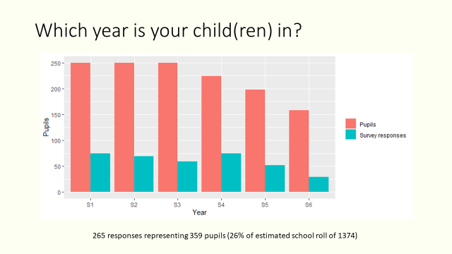
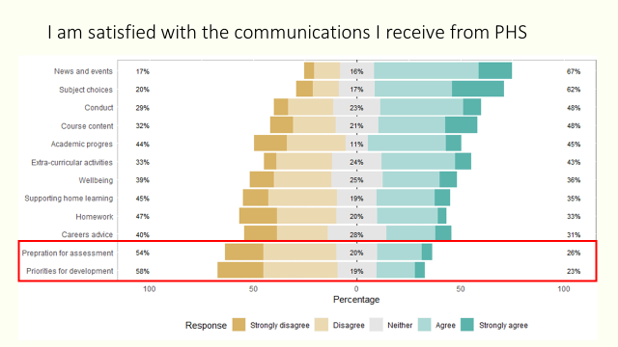
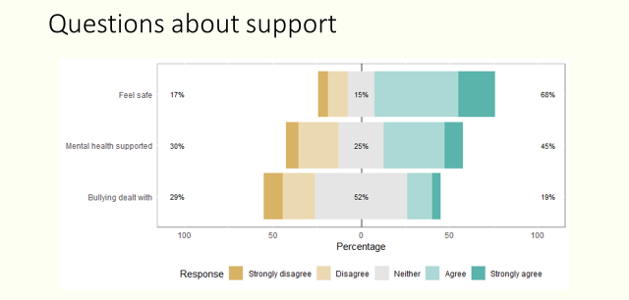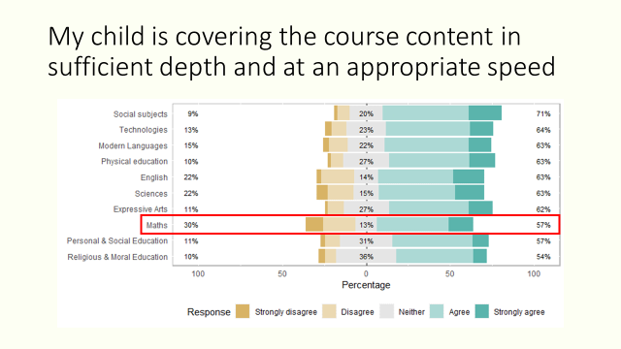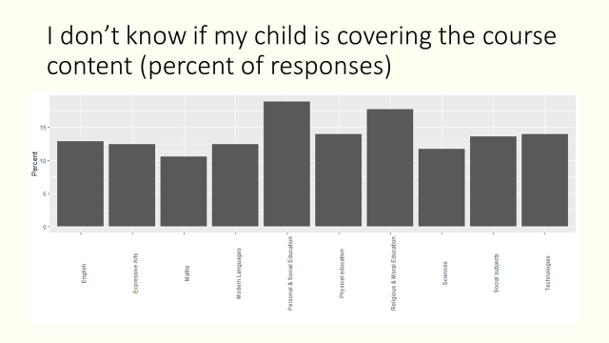
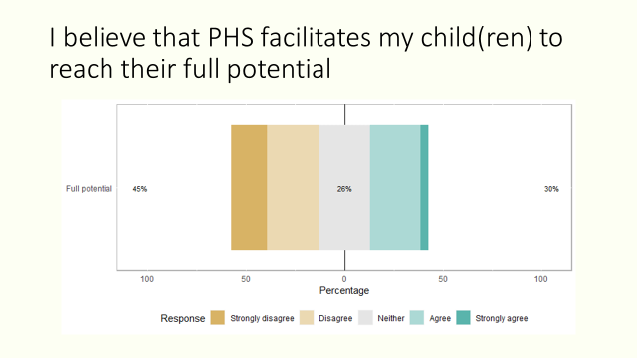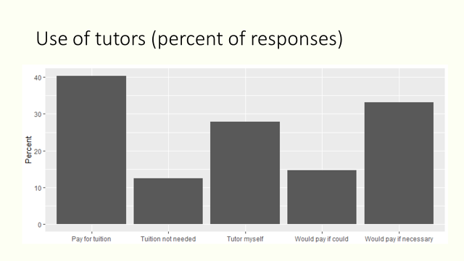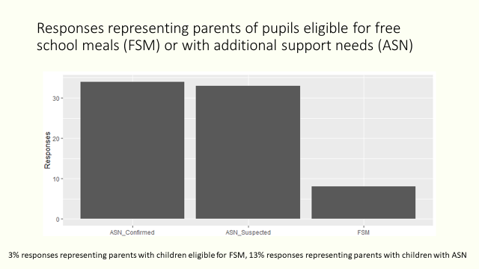
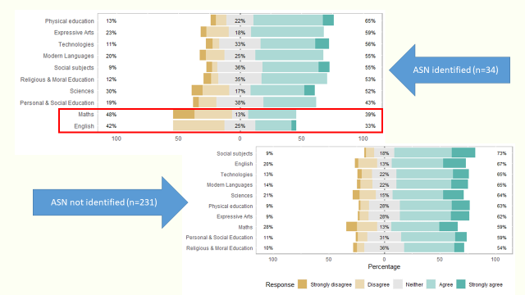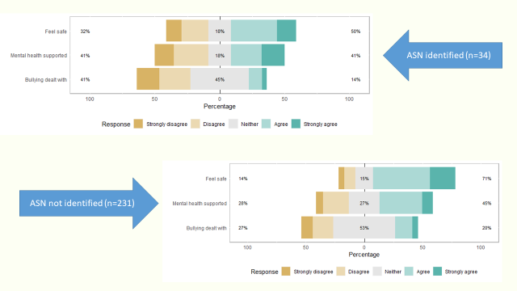

Helpful Information

Parent Council Meeting dates 2021/22
Tuesday 31st August 2021
Wednesday 20th October 2021
Thursday 18th November 2021
Tuesday 18th January 2022
Wednesday 2nd March 2022
Thursday 21st April 2022
Tuesday 7 June 2022 (AGM)

Post Holders
Chair - Sarah Duncan
Vice Chair - Susan Jarvis
Secretary - Claire Barrett
Comms - Judith Ackerman
Taskforce - Rachel Beatton
Events - Dee Hollingsbee & Elodie Seller

Working Group leads:
Friends of Peebles High School SCIO representative - Eric Nightingale
Teaching & Learning - Alex Corbishley & Susan Jarvis
Property - Sarah Duncan

We welcome interested parents & careers on the Parent Council as general members or working group members. We simply ask that you try to attend meetings regularly. If you would like to be an ordinary member or join a specific working group, please email your details to: phspc@outlook.com

Website: www.phsparents.org.uk
Twitter: @PHSparents @PeeblesHigh

