PHS Parent Council
18 November 2021
Teams Meeting

Attendees:
Sarah Duncan, Chair, Parent Council (PC)  Campbell Wilson, Headteacher  David Flynn, Treasurer  Eric Nightingale, Chair, Friends of Peebles High School SCIO  Claire Barrett, Secretary | c. 30 parents attended

Minutes
Welcome, Approval of Minutes, Update on Actions Sarah Duncan, Chair
The Chair welcomed everyone to the meeting, the previous minutes were approved. Apologies were received from Muriel Foreman.

Chair’s Update Sarah Duncan, Chair
- Working groups are up & running and will report on progress at next meeting – new members welcome to join
- Focus group on progress reports will be meeting in the next few weeks
- Survey on Community/Family Learning is issuing tomorrow, please complete it
- Letter from 8 Secondary Parent Councils has been sent to SBC to raise concerns over this year’s school budget cuts – we will update parents when we hear back.
- Awaiting update on the new school plans - nothing from SBC as yet. Will update at January meeting (or before if significant).

Friends of Peebles High School Update Eric Nightingale

Fund: | Restricted £ | Unrestricted £ | Total £
LSPHS | 2,152.67 |  | 2,152.67
Fire Fund Balance | 5,000.00 |  | 5,000.00
2018-19 O/S Bids Process | 3,417.00 |  | 3,417.00
General Unrestricted |  | 6,517.98 | 6,517.98
Total Funds @ 31-07-21 (per accounts) | 10,569.67 | 6,517.98 | 17,087.65
Lottery draw surplus t/f to FPHS in Sept 2021 |  | 637.04 | 637.04
Cancellation of 2018-19 O/S Bids | -3,417.00 | 3,417.00
Total Funds @ 17-11-21 | 7,152.67 | 10,572.02 | 17,724.69

The above table reflects the accumulated funds currently available to meet the requirements of the 2021/22 school bids process.

Starting with the position at the end of July 2021 (1st bold sub-totals) you will see:
- We brought forward £17,087 funds in total, of which £10,569 was held for specific purposes.
- In September, funds were increased by £637 via the results of the Sept Lottery draw.
- As it has been agreed between the PC & PHS that the outstanding 2018/19 bids have effectively lapsed, this amount can now be effectively reabsorbed into general reserves. That’s because the 2021-22 Bids process now incorporates all current needs.
- This indicates total funds now stand at £17,724.
- Assuming the 2021/22 bid process is agreed, this means there are adequate funds to meet the £6,571 requested in full (more details later). Especially since £2,125 meets the criteria permitting utilisation of the LSPHS fund.

Pipeline events
- Sales of Peebles Eats vouchers are estimated to be circa 150 booklets out of the 500 printed, raising approximately £600.
- Production of the 2022 Calendar is underway and an order to produce 300 copies has recently been placed. If all are sold this will result in around £800 profit.
- Meeting arranged with Mr Charles Gray, Independent Examiner, on 23 November to formally sign off the accounts.

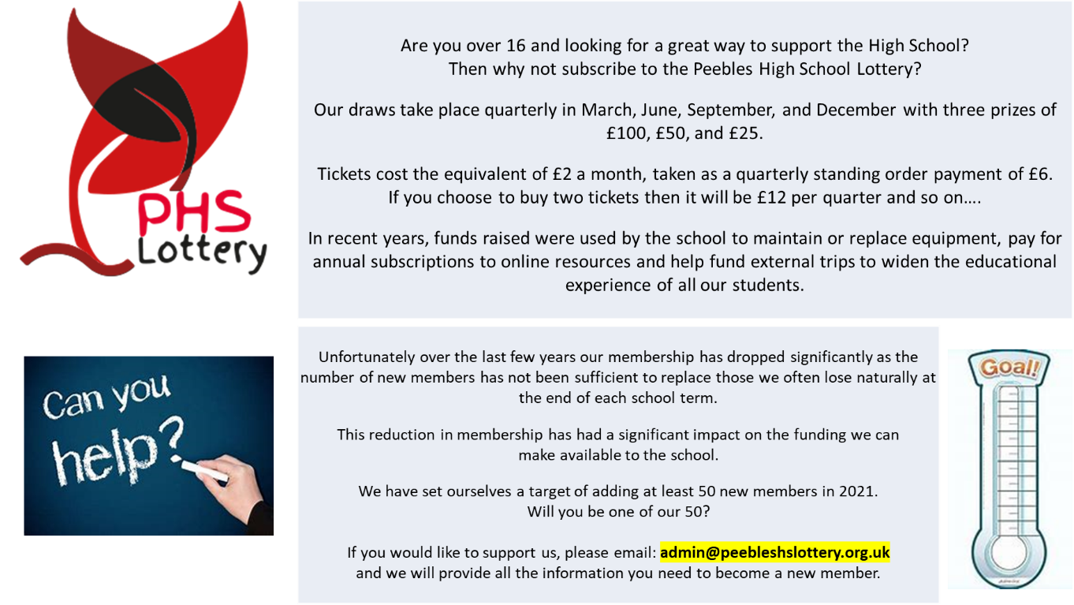
A plea to join PHS Lottery

Distribution of funds
15 bids were received from the school totaling £10,371, details provided at end of minutes.
Friends of Peebles High School Trustees proposed allocating £6,571 to the following bids:
- Support for Learning - £2,125
- PHS Pride - £1,830
- Drama - £216
- Take What you Need Trolleys - £400
- Business & Computing Technologies - £500
- Politics Library - £500
- Wellbeing Boxes - £1,000

A vote was taken and the Parent Council agreed to the recommended distribution of funds.

A question was asked about what happens after the 1st year of funding. The FoPHS charity would commit to initial funding – eg the Stewart Project is a pilot. The impact would be measured and reviewed at a future funding round.

More info on Netball Club bid – how does it work – most of other clubs are part of PE but the netball club is not and it’s not run by PE teachers. Do the other sports clubs get funded by the PE dept? Mr Wilson confirmed that all extracurricular clubs are self-funded by members, not the school or departmental budgets.

How much is left in the Opportunity Pot? We raised just over £12k in Oct ’19, just before the fire. There is still just over £10k in the pot. Spent mainly on taxi fares to enable pupils to take part in activities they otherwise couldn’t get to.

Rector’s Update Campbell Wilson, Head Teacher
Covid:
There have been mercifully few +ve Covid cases in recent days and weeks but, sadly, we cannot adjust our risk assessments based on the prevalence in our own community alone while it remains so prevalent in the nation as a whole. Staff and young people are increasingly wearied by the ongoing limitations to the full experience of school life imposed by Covid safety measures. It looks unlikely that we will be able to organise Christmas Social Events for young people. A meeting with all Secondary HTs to discuss the possibility of having Christmas Dances at off site venues such as the Hydro takes place at 8:15 tomorrow morning. We did this in 2019 and, while it was not quite the same as decorating our own hall, the kids had a great time and we were very well supported by staff and parent chaperones. I will update parents via letters home next week with a decision on this topic. The S6 in particular are desperate to know if they can have their last ever Christmas Dance in Peebles.
Staggered Lunches and breaks:
We made good progress with our first Short Life Working Group meeting to plan the return to single lunches and breaks. I am now confident we can offer all young people a seat to eat their lunch, a reasonable queuing experience and a quiet space to be should they desire peace at lunch time. Crucially, a full return to extra-curricular lunch activities looks viable under our new model for lunch. When the face-masks come off we are all going to enjoy being a more vibrant, orderly and safe place at lunchtimes than we have been able to enjoy for many years.
Staffing:
Paulin Draganova has joined our English Department as backfill for Simon Charles’ secondment.
Katie Deighan has joined our History team to cover the end of Lee Thornborrow’s maternity.
School Calendar and Parents’ Evenings:
I hope that you have all received your copy of the school calendar and accompanying letter on Parents’ Evenings this week (possibly just today). Apologies that the Parent version is so drab and bare compared to the version we use in school. We had to remove all of the photographs and artwork to reduce it to a size where the pdf could be attached to a Group call email. All of the dates are there though. I know that there is frustration at the number and timings of Parents’ Evenings but their positioning in the year is carefully considered for reasons that best support learning and the cycle of the school session. I am slightly apprehensive of the video link technology working smoothly on 7th December but Gala Academy have had great success with their evenings to date. The system is effective at keeping appointment times strictly to the five minutes allocated and then moves you seamlessly on to your next appointment. Not the same as face to face but the best we can do. Help will be offered to families that might struggle with reliable broadband in advance of our planned evenings.
S2/3 Residential compensatory events:
We are planning fun team building and values based days ‘off timetable’ in early May or June 2022 for our S2s and S3s.
School Website:
Justin Noon has started to build a new school website that will be far better and easier for the school to update and adapt than our current site. He is at the stage now where he is looking for parent voice to help shape our website. Tonight I am looking for two or three parent volunteers to meet with Justin to give their views on what our new website might look like and include. I will pass names to Justin and he will make contact to set up a meeting soon.
No SQA update this month as very little has changed. We’re still planning for prelims in Jan – Feb (see calendar for dates) we know Covid is still a risk, contingency planning is in place.
Chris Knight and Tristan Compton volunteered to help with the website.
Open Q&A session Campbell Wilson, Head Teacher
S1 residential falls on the Queen’s birthday school holiday – can you confirm it will be the full week and not cut short?
The week will not be cut short and yes we return on the day of the holiday.

Will there be study leave for prelims and exams this year?
Yes, study leave will happen if allowed within schools guidance.

What are the Prelim dates?
Monday 17 Jan for about 14 days – please see school calendar
Mr Wilson addressed the concern from last PC meeting about quality, detail and quantity of reports, accepting that this needs to be better. Mr Wilson confirmed it is an aspect of the next School Improvement Plan (SIP) for 22/23 and asked parents to be patient. Full info on how to book for 1st parents evening is coming out next week.

What is being done to help pupils catch up after the disruptions of Covid?
Education Scotland and HMIE made it clear after last session that this year should be about recovery of learning. Staff are saying that despite what they’ve been through, young people are not off track where they should be. If anything, it is more about socialization issues, rather than gaps in learning.

Homework – what is the school policy?
I took feedback at last parent council and wrote to staff about h/w and I hope that Parents of S1 and S2 have seen a more consistent use of Satchel One and that there’s been an increase in h/w in S1 and S2. There is no rule about number of hours of h/w per week. But at S1/2, a couple of hours a week is ample to consolidate learning from school at home. Obviously more for seniors. Parents mentioned there was still little use of Satchel One.

I’m concerned that because of COVID and the fire pupils are managing to maintain their educational performance but at a large cost to their mental health. I appreciate the additional resources Kooth and Quarriers put in place but is there any ScotGov/SBC increase in resources to the Store or pastoral care to support pupils?
Kooth and Quarriers were signficant investments from SBC and ScotGov and the school could not have afforded this. A significant number of pupils are using this after school hours so it has been put there for a reason and it is being used.

Is Mr Wilson in Physics anymore? Could you please explain how this teaching will be picked up as current teacher is not yet trained for N5.
Mr Wilson has returned to Hawick High School.
Action: Mr Wilson to look into concerns around delivery of N5.

Last meeting we spoke about access to daily bulletin from Teams now that it’s no longer on the website…I’ve had a good look with my daughter on Teams and we can’t find it. Can some sort of link be sent?
Action: Mr Wilson to look into this.

Is the Burns Supper in the middle of Prelims? S6 particularly
That won’t happen, that’s an error.

Could the calendar with childrens’ artwork on it could go on school or the website ?
Action: Sarah Duncan to talk to office.

Will there be a Christmas Concert?
Yes, we hope to have a concert. It may be recorded and/or livestreamed.

When will children know the prelim timetable for each subject?
Before Xmas but not until we’ve had clarity from SBC about what the exam experience will be.

Mr Wilson expressed his thanks to the Parent Community for the funds allocated to the successful bids as previously covered.
The meeting closed at 8pm
Next meeting: Tuesday 18 January, 7pm

______________________________________________________________________________________
Helpful Info/Reminders
Parent Council Meeting dates 2021/22
Tuesday 31st August 2021
Wednesday 20th October 2021
Thursday 18th November 2021
Tuesday 18th January 2022
Wednesday 2nd March 2022
Thursday 21st April 2022
Tuesday 7 June 2022 (AGM)

Post Holders
Chair - Sarah Duncan
Vice Chair - Susan Jarvis
Secretary - Claire Barrett
Comms - Judith Ackerman
Taskforce - Rachel Beatton
Events - Dee Hollingsbee & Elodie Sellar

Working Group leads
SIP Priority T&L Framework - Susan Jarvis & Alex Corbishley
Property - Sarah Duncan
Friends of Peebles High School SCIO representative - Eric Nightingale

We welcome interested parents & careers on the Parent Council as general members or working group members. We simply ask that you try to attend meetings regularly. If you would like to be an ordinary member or join a specific working group, please email your details to: phspc@outlook.com
Website: phsparents.org.uk
Twitter: @PHSparents @PeeblesHigh

Funding Bids 2021/22

