PHS Parent Council
18 January 2022
Virtual Meeting

Minutes

Attendees:
Sarah Duncan, Chair, Parent Council (PC)  Campbell Wilson, Headteacher  Susan Jarvis, Teaching & Learning Working Group  Claire Barrett, Secretary | c. 26 parents attended

Welcome, Approval of Minutes, Update on Actions Sarah Duncan, Chair
The Chair welcomed everyone to the meeting, the previous minutes were approved. Parent Council Treasurer is now David Flynn, not Eric Nightingale. The previous minutes will be amended to reflect this.

Update on Actions:
- Daily bulletin will now be uploaded to Year Group Teams and can therefore be viewed on pupil’s iPads.
- Physics teaching - Mr Wilson has returned to his substantive post in Hawick HS and the post will be advertised soon.

Chair’s Update Sarah Duncan, Chair
- Ipad connection issues over festive period were now resolved.
- Covid mitigations in school continue as per last term so parents were asked to remind pupils to wear masks and encourage regular lateral flow testing.
- Prelims commenced yesterday for S4-6 pupils with study leave provided throughout. It was confirmed that any pupil who misses an exam due to an authorised absence should speak to their teacher on their return to arrange an alternative assessment.
- Secondary Parent Council chairs are meeting with SBC on 20 January regarding school funding levels with the aim of highlighting the recent cuts to Devolved School Management budgets as having a real impact on pupils. We are hoping to influence next year’s budget therefore if this meeting doesn’t provide reassurance then the next step will be to contact elected members. If you feel strongly about school level funding being protected, please share your views on the SBC budget survey by 30 January: https://www.scotborders.gov.uk/budget
- There were ongoing littering issues in the vicinity of the school, especially on Springhill Road and Victoria Park. Parents were asked to speak to their children about the issue.

Funding Allocations

The following update to allocation of funds was formally approved:
Support for Learning £2,125
PHS Pride £1,830
Drama £216
Music £540
Photography £845
Business & Computing Technologies £500
Politics Library £500
Take What you Need Trolleys £400
Wellbeing Boxes £1,000
Total £7,956

Property Working Group Update Sarah Duncan

Sarah confirmed that a working group meeting was scheduled for 26th January and a meeting with SBC project team in early February. The current timeline for construction to start is late 2022 and completion by end of 2025 which will require the planning application to be submitted very soon. BAM Construction would be the contractor and they have significant experience building schools across the UK. Galashiels Academy will be progressed with similar timelines but with a different contractor.

Questions raised:
Could we have sight of the output from the public consultation? It should be shared prior to planning permission being submitted. We have asked for this information but have received no response as yet.

Will the new school have a library staffed by a qualified librarian? SBC are expecting to be able to give us an update at our April meeting on the future of school library services.

Will the arts be given the same weight as sports in the new school building including performance and practice space? The architects have been made aware of the historic success of pupils across all faculties and that the new facilities should support this to continue.

We understood end 2024 was the date for populating the new building, with final completion (including all demolition and landscaping) end 2025. We will ask for clarity on the timeline but this is also our understanding.

What’s happening with the running track and rugby pitch during the build, and the long jump pit? We’ve asked for the new 3G pitch to be provided at the start of the project so that we don’t have no pitches during construction. Athletics facilities being provided have not yet been confirmed.

What are the plans for lunchtime facilities - we have a large number of young people and would be good to achieve a nice, appropriate place for them to sit, eat and socialise. This has been raised as we are keen to make lunchtime a more positive experience for all pupils. Newer schools tend have an open plaza area with a range of seating options and serving hatches rather as a dedicated canteen hall and we expect similar to be provided.

Teaching & Learning Working Group Susan Jarvis

Susan presented an update on the working group remit, aims and activities (see appendix for full details).

Parents were encouraged to complete the parent experience survey which would be circulated by Groupcall. The results would feed into the School Improvement Planning process and the aim was to build up data year on year. The survey has been robustly reviewed and input sought from a range of parents.

If you’d like to get involved with the Teaching & Learning Working Group please email phspc@outlook.com

Rector’s Update Campbell Wilson

Covid:
After having been braced for a “Tsunami” of Omicron after Christmas, the reality has been very welcomingly underwhelming with very few cases in our school community.

Staggered Lunches and breaks:
Despite the positive picture around Covid, there is no complacency and local advice has been to continue with staggered intervals and lunches albeit young people can now enjoy sitting indoors for lunch.

Staffing:
Notable changes in Pastoral with Lisa Edge leaving to take up a post at Kingsland Primary School and Rachel Hyatt giving up her Pastoral PT status to return to her substantive post as English teacher. A combination of Mr Shirra Gibb and a new internal appointment (interviews next week) will be taking on the caseload. I appreciate that there has been significant changes in Pastoral caseload this session and that it is disruptive to the good support of your children, however I am confident that this will settle down into next session. A further change has taken place in Science with Mrs McDowell changing from PT Bio/Chem to class teacher for 18-month secondment. We have recruited Jenny Allen to the PT post and she starts after the February break. Mrs Minto is also covering Carys Hogg’s departure in Biology.

School Calendar and Parents’ Evenings:
Online Parent evenings are receiving positive reviews and are published in the calendar. Next up is S3 on 27th January.

S2/3 Residential compensatory events:
Letters were issued for these events yesterday – fun days of values-based activities. Bused to and from the school within the school day in May.

School Uniform:
Letter coming out this week to launch a push on raising standard of uniform and strategies to improve it. I hope you find this supportive in your conversations at home. Notably, shoes should be plain black and sports shoes with white soles or logos are not deemed to meet uniform policy. Jackets will continue to be allowed to be worn in classes whilst the windows are open for Covid.

Prelims:
Very positive start to the prelim diet yesterday and today. Delighted to see young people given the chance to have a dry run before the main event in May.

School Website:
Our new website is making good progress and will launch before the end of March.

Open Q&A session

Can we reschedule any Parents’ Evenings appointments that were cancelled by the teacher?
Parents were advised to email the school office, making the subject FAO (for the attention of) the member of staff and request a phone call with them to discuss your child’s progress.

We raised the use of black trainer/converse shoes years ago and it was permitted as long as the logo was black. Are plain black Converse ok?
Yes, no issue with individual brands as long as the shoes are plain black.

Can the location of prelims be published in advance of the day?
They’re either sports hall or assembly hall (unless additional arrangements are in place and will be LRC).
NB: Mr Wilson’s letter of 21/1 confirmed that location cannot be published in advance.

Kids missed out on their Christmas parties. Could they be replaced by a Burns/valentine/spring parties?
Dances will be reinstated as soon as allowed but this has not yet been approved and is Covid dependent.

What is the smoking policy for building contractors operating in school grounds outside of normal school day – on Saturday morning at the sports hall there were contractors working. Large number of pupils were at the school for sports and had to walk through the smoke.
It was confirmed external contractors shouldn’t be smoking on school premises at any time, including Saturdays.
Action: Mr Wilson to raise this with Gareth Smith, Clerk of Works at SBC

Litter issue – Victoria park steps – kids climbing over the wall into Victoria park
Councillor Robin Tatler has been really helpful and has confirmed he will progress repair of steps which should reduce the problem with littering and prevent further damage to neighboring properties. However, no date as yet for repairs to be carried out.

Pastoral support – What is the reasonable response rate, how long should you wait for a reply?
School’s internal email policy is 3 working days. If you haven’t had response from pastoral in that time, please email Donna Moretta (via office) to escalate it.

Advanced Higher Biology – when can we expect permanent cover and can temporary cover be provided?
Mrs Minto is providing temporary revision support for the other class. Classes can’t be combined due to legal restrictions on class numbers. Cover should be confirmed on arrival of Jenny Allen but this will be checked.
Action: Mr Wilson to check cover for Higher Biology class

When does study leave end?
Study leave is up to and including 2nd February, so classes resume Thursday 3rd February.

Pastoral changes – some S1 pupils already on 3rd teacher which is not ideal for forming relationships
Mr Wilson agreed that the situation had not been ideal and confirmed pastoral staffing had been more unsettled in the past 2 years than he could remember in any other year which does have an impact on young people. He apologised for the recent situation but confirmed that SBC doesn’t currently allow appointment of permanent promoted posts therefore he can only promote internally for temporary positions which is a real challenge.

An update on the proposed new pupil support structure presented in Dec 2020 was requested.
It was confirmed that SBC were conducting their own review of pupil support across the whole authority which was preventing the changes to structure being implemented. It was hoped planned changes to the support system would provide more consistency in support and Pupil Support Assistants would reduce Pastoral workload.
Action: Sarah Duncan to raise issue of freeze on permanent posts with SBC (previously raised but no response).

Free Bus Travel - new NEC /Young Scot card can be activated to enable free bus travel for 15 – 22 year olds.
SBC are referring parent to school to apply if unable to use online NEC form, is this right?
Mr Wilson not aware of this therefore Parent Council will check position with SBC.
Action: Sarah Duncan to clarify with SBC how to apply for new NEC/Young Scot cards.

Activity Days for S2/3 – can we have more detail and costs please?
£52 for day of activities – 2 morning, 2 afternoon (eg high ropes, team building activities). £12 discount for anyone on free schools meals/clothing grant. If this cost is still challenging please call Mr Wilson and he can consider further support available based on circumstances.

The meeting closed at 8.10pm

Next meeting: Wednesday 2 March, 7pm

Helpful Info/Reminders

Parent Council Meeting dates 2021/22
Tuesday 31st August 2021
Wednesday 20th October 2021
Thursday 18th November 2021
Tuesday 18th January 2022
Wednesday 2nd March 2022
Thursday 21st April 2022
Tuesday 7 June 2022 (AGM)

Post Holders
Chairperson - Sarah Duncan
Vice Chair - Susan Jarvis
Secretary - Claire Barrett
Comms - Judith Ackerman
Taskforce - Rachel Beatton
Events - Dee Hollingsbee & Elodie Seller
Treasurer – David Flynn
Teaching & Learning Working Group Leads - Susan Jarvis & Alex Corbishley
Property Working Group Lead - Sarah Duncan
Friends of Peebles High School SCIO representative - Eric Nightingale

We welcome interested parents & careers on the Parent Council as general members or working group members. We simply ask that you try to attend meetings regularly. If you would like to be an ordinary member or join a specific working group, please email your details to: phspc@outlook.com

Website: phsparents.org.uk
Twitter: @PHSparents @PeeblesHigh

Appendix – Learning & Teaching Working Group

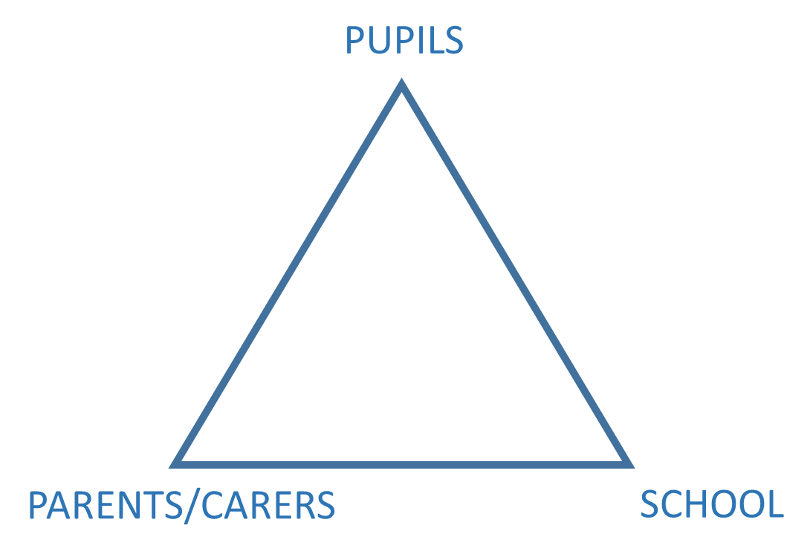
Working Group Remit
Our remit is to align activities with the School Improvement Plan 2021/22 by:
- Supporting communication and engagement in learning activities between pupils, parents/carers and the school
- Support learning at home through empowering parents/carers to use the Learning Structure to support their children
- Supporting the school and providing advocacy for young people and their families with respect to the school’s mission to meet the learning needs of all pupils

Members:
Susan Jarvis, Alex Corbishley, Dawn Johnstone, Viv Leckie, Elouise Johnstone, Ruth Doherty, Mairi Stark, Tristan Compton, Amanda Peppe, Martha Cadedell, Vicki Swan, Dave Weipers, Elodie Sellar & Tyne Lovell

SIP Priority 1 - Continuous Improvement to Learning, Teaching and Assessment

Measures of success
- Teaching staff will use the Learning Structure in almost all lessons.
- Teaching staff will develop a shared understanding of all aspects of the Learning Structure and apply them consistently.
- Young people will be supported to apply the Learning Structure to their own learning.
- Parents will be supported in how to apply the Learning Structure at home to improve learning.
- Faculties will engage in a termly collaborative professional enquiry focused on an element of the Peebles High School Learning Structure.
- Open Doors, whether they are face-to-face or a digital alternative, will support faculties to identify their key strengths and areas for development.
- The voice of all stakeholders and in particular the voice of young people will be more prevalent in evaluating quality across all areas of the school.
- Continuous improvement around our Peebles High School Teaching and Learning Framework will be the core focus of all departmental meetings, after school meetings, extended leadership meetings and in-service days.
- Faculties will use their collegiate time to engage in ongoing professional learning aligned to their identified area for improvement from the Learning Structure.
- Teaching staff will share their practice across the school and will engage
- Parents will better understand how their child is learning and developing and will feel empowered to support their child’s learning at home.

SIP Priority 2 - Ensuring Wellbeing, Equality and Inclusion
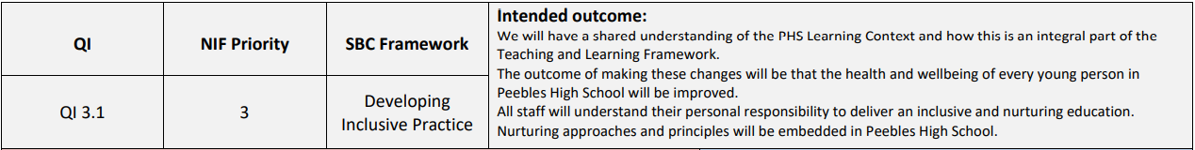

Measures of success
- Staff will be confident in using nurturing approaches in their dealings with young people
- Almost all young people will feel respected, included and safe
- Almost all young people will feel comfortable approaching staff with questions or suggestions
- Almost all young people will feel they are treated fairly and with respect by staff
- Teaching staff and young people will have a shared understanding of the wellbeing indicators
- Faculties will demonstrate how the indicators are included within their curriculum
- Pastoral staff will be able to track the wellbeing of young people in their cohort and provide or signpost appropriate supports
- Teaching staff will be confident in the use of wellbeing indicators to support young people develop an understanding of the importance of wellbeing
- There will be fewer duty calls and teaching staff will feel more empowered to deal with incidents by applying restorative approaches to repair relationships with young people
- Duty will be used to support restorative conversations rather than as a sanction

Success criteria – Supporting Learning at Home
- Support a review of formal and informal communications to parents about their child’s learning
- Careers – support bringing the community experience into school
- Supporting Community Learning: e.g. STEM and Eco-committee activity

Outcome | Aim | Target Date
Feed into the review of tracking & monitoring reports and the format of parent evenings | 1 | March 2022
Feed into the development of a new school website | 1 | March 2022
Careers sessions online for senior pupils | 2 | Dec 2021
Support career skills sessions for all year groups | 2 | April 2022
STEM Leaders training, STEM learning day(s) | 3 | April 2022
Eco-group activity | 3 | May 2022
Support development of a family learning programme for 2022/23 | 3 | May 2022

Success criteria – Learning Context
- Engaging with Donna Moretta (Depute Headteacher leading on the Learning Context)
- Meeting with PHS Support for Learning department to understand existing provision and resources
- Establish a longitudinal PHS PC parent survey - PC does not have access to longitudinal data from parents, we feel it is essential to collect objective data to guide future priority areas in the SIP
- Work with PHS Pupil Parliament - design, distribute and analyse a student experience survey

Outcome | Aim | Target Date
Collect objective data relating to parent/carer experience | 3 | Jan 2022
Updated information relating to Support for Learning in the school handbook and on the new PHS website | 1 & 2 | March 2022
Collect objective data relating to pupil experience | 4 | March 2022
Present pupil and parent survey findings to pupil parliament, parent council and SLT | 3 & 4 | April 2022

