PEEBLES HIGH SCHOOL PARENT COUNCIL

Parent Council Meeting
20 August 2020
Teams Meeting

Parents Open Forum – all years

Attendees:
Glenda Barton, Chair, Parent Council (PC) | 37 parents attended
Campbell Wilson, Head Teacher (CW)

Minutes
The Chair welcomed everyone to the meeting and took the participants through the vision, purpose and roles in the Parent Council , welcoming new parents to participate.

The AGM minutes were approved apart from one small amendment. There was an error on P7 - the number of Highers predicted was 36.9% not 39.6%.

It was with great sadness that we learned of the death of Mr Alan Stewart, learning support teacher. The PC has sent our condolences to his family.

PC Chair then handed over to Mr Wilson who shared the School Improvement Plan ( SIP) and the SQA results of the school.

The Parent Council would like to congratulate the school on those results especially in light of the incredible difficulties the teachers and students had to cope with. Thank you and well done to everyone!

Open Forum Q&A

Is there a possibility of more S6 study space? What provision is there beyond the atrium?
The atrium can accommodate a fair number socially distanced. This session we have more students than ever before (1363) and less space than ever before (since the fire). The assembly hall can also be used (50 desks), so with the change in timetable we will encourage snr students away from the atrium and into the assembly hall which is quieter and more spacious, one desk each, strict rule. Wipes are available for everyone to wipe down their workstation before and after use. This will be until restrictions are eased.

What is the situation with signing out (seniors)
CW shared slide (see appendix) that students have been shown. If you have non-contact study period/college and you wish to sign out and study at home you may do so only if you have permission from home. Your parent must email Rebekah.laidlaw@scotborders.gov.uk. If we have not received an email we can’t allow you to sign out. We must know who is in the building!

Are there going to be timetable changes next week with triple periods? Will there be teacher changes? Will there be regular breaks?
The timetable will change the week after next. The reason for the changes is to make the school more covid-safe by minimising movement around the school. There will be triple periods, but there will be no teacher changes.
Yes there may be breaks but it will be more about structuring lessons well and breaking up learning into chunks.

What was the thinking behind triple periods? Why not more double periods, or an alternate fortnightly timetable? What about concentration / productivity of pupils over this long spell?
Triples and doubles was the best way for PHS to do it without changing everyone’s teachers

We were challenged to reduce movement further around the school. The one way system helps this but longer periods really decreases movement in the school further, so we are trying to do everything we can feasibly do to stay open. We are considering everything possible, but can only do what we can deliver, and this is one thing we could do.
Allowances will be made for pupils with additional needs.

When will extra curricular groups be starting up again?
There can be no extra curricular activity until SBC say so. This applies to both indoor (eg debating, orchestra) and also all sports.

If there is to be no music tuition why are SBC are still charging fees for tuition?
The PC will check this with SBC

What would be the triggers to move to plan B to be at home if there is a covid issue?
SBC contacts the Scottish Govt and the Test and Protect system kicks into place. We are trying hard to avoid this with the safety measures we have in place but there is very clear guidance on what we do in this scenario. Home learning/blended learning could be used again seamlessly.

If individual children/families have to isolate due to covid can lessons be live streamed?
The two biggest teaching unions are advising their members not to do it but PHS is not discouraging our teachers from live streaming.

Have S1s had a fire drill?
Every S1 was taken to fire muster points on the first day and told where to go if the fire alarm sounds.

Mr Wilson update

School Improvement Plan - Mr Wilson shared a slide on the SIP (see appendix)
Leadership & Management/Learning Provision – Mr Wilson would like to explore with the PC possible ways of parental involvement including possibly open door days.

A new PT on Learning & Teaching will hopefully be appointed in the near future too.

Results – Mr Wilson shared slides on the SQA results for PHS (see appendix)
Our 3 key targets and results were:
Target: 90% of S4 to attain 5 qualifications at any level*
We achieved: 85.3% of S4 attained 5 qualifications. After the Scottish Govt turnaround this was upgraded to 91%

Target: 35% of S5 to attain 5 Highers in S5
We achieved: 34.7% of S5 attained 5 Highers. After the Scottish Govt turnaround this was upgraded to 37% (our best ever results)

Target: Over 60% of S6 to leave us with at least 5 Highers
We achieved: 76% of our S6 leave with 5 Highers

26 young people attained 5 As at Higher in S5 this year!

The Scottish Government U-turn means PHS will not look as good in the league tables as it would have, but the revised grades are welcome for individual students.

Positive destinations leaving school – this is an area of concern due to Covid-19 and the job market.

Attendance is at 95% since school opened this session.

The PC would like to thank staff for the efforts they went to for our young people after the fire with putting forward evidence for SQA.

How does this affect number of subject choices (the parent survey on curriculum)?
When choosing subjects in 4th year it’s based on what outcomes you are aiming for eg if it’s 5 Highers in first sitting with current system then 6 N5s have shown the highest probability for good results which we have done to date. If it’s Highers by the end of 6th year then probably can take more in 4th year. We are looking at the curriculum just now to see what the best option might be. However it’s a really hard question to answer .

Is repeating S6 allowed?
It is unusual but it is allowed.

Is there an update on the school rebuild?
Update from Catriona Bhatia: The design team have worked hard during the summer to refine the possible options that balance off ease of construction, disruption to pupils and civic presence. At the moment, this work is drawing to a close with the cost estimate being updated. It would be intended to present the emerging proposal and cost estimate to SBC's Corporate team/Members in the first instance prior to a wider stakeholder strategy being developed for community consultation.”
If any parent is interested in being part of the project team please get in touch with the PC.

Appendices:
- Treasurer’s Report (no time to cover in meeting)
- Mr Wilsons’s slides:
- Seniors Signing Out arrangements
- School Improvement Plan (SIP)
- Results 2020

TREASURER’s REPORT FOR PARENT COUNCIL MEETING

THURSDAY 20th AUGUST 2020

Current Bank Balances:

Bank Account | Today | At 31/03/2020 | Movement
 | £ | £ | £
PC Main A/C | 31,819 | 31,319 | 500
Lottery A/C | 3,440 | 2,233 | 1,207
Total | 35,259 | 33,552 | 1,707

The £500 balance increase in the main account reflects the receipt of a fire fund donation of £500 from Hymans Robertson Foundation in May 2020.

The £1,207 Lottery account increase is the result of additional ticket sales less the £175 prize distribution in June 2020. The next draw is due to take place on 14 September 2020.

Fire Fund and 2018/19 Bid Process Balances:

Included within the above cash reserves is unspent monies totalling £21,889 received from the Fire Fund raising initiatives and £3,417 left over from the 2018/19 school resource bid process.

A schedule summarising the decisions made during the June AGM for the benefit of school departments has recently been provided to Mr Wilson. Together with details of those departments owed money from the 2018/19 bid process to aid his upcoming discussions with departmental heads.

Charity Update.

Further to the AGM communication about our application to create a charity: Friends of Peebles High School (SCIO) I’m pleased to report that OSCR has now accepted our application and the charity was official registered on 3 July 2020.

Owing to the difficulties associated with Covid-19 the major Banks are however not currently inviting applications for new Business or Community Banking accounts. That decision has significantly delayed conclusion of the charity, particularly because a bank account is imperative for registration of Gift Aid eligibility with HMRC.

We are currently exploring networking opportunities as a way around this present difficulty.

Eric Nightingale
20 August 2020
Mr Wilsons slides – Snrs signing out arrangements

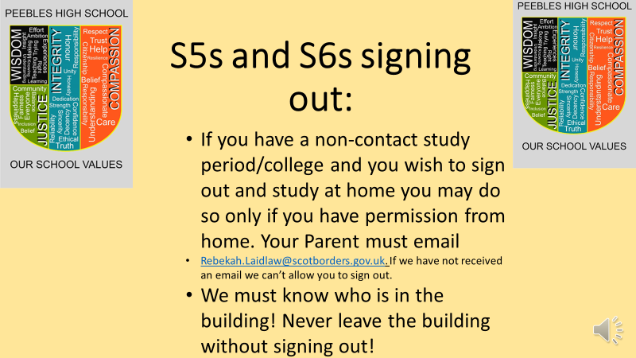

Mr Wilson’s slides - School Improvement Plan (SIP)

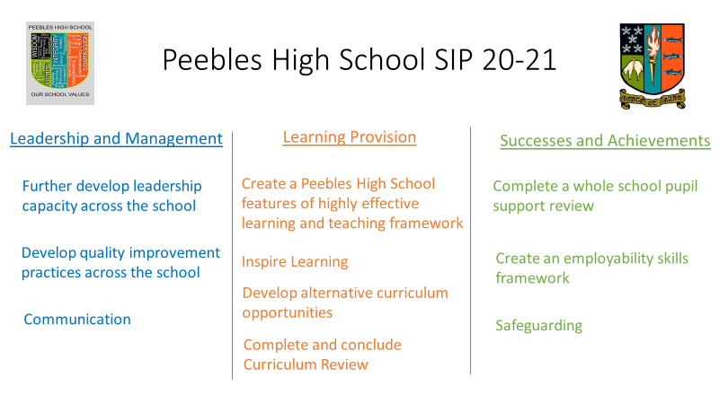

Mr Wilson’s slides - Results

